2020 Dolphin Duals

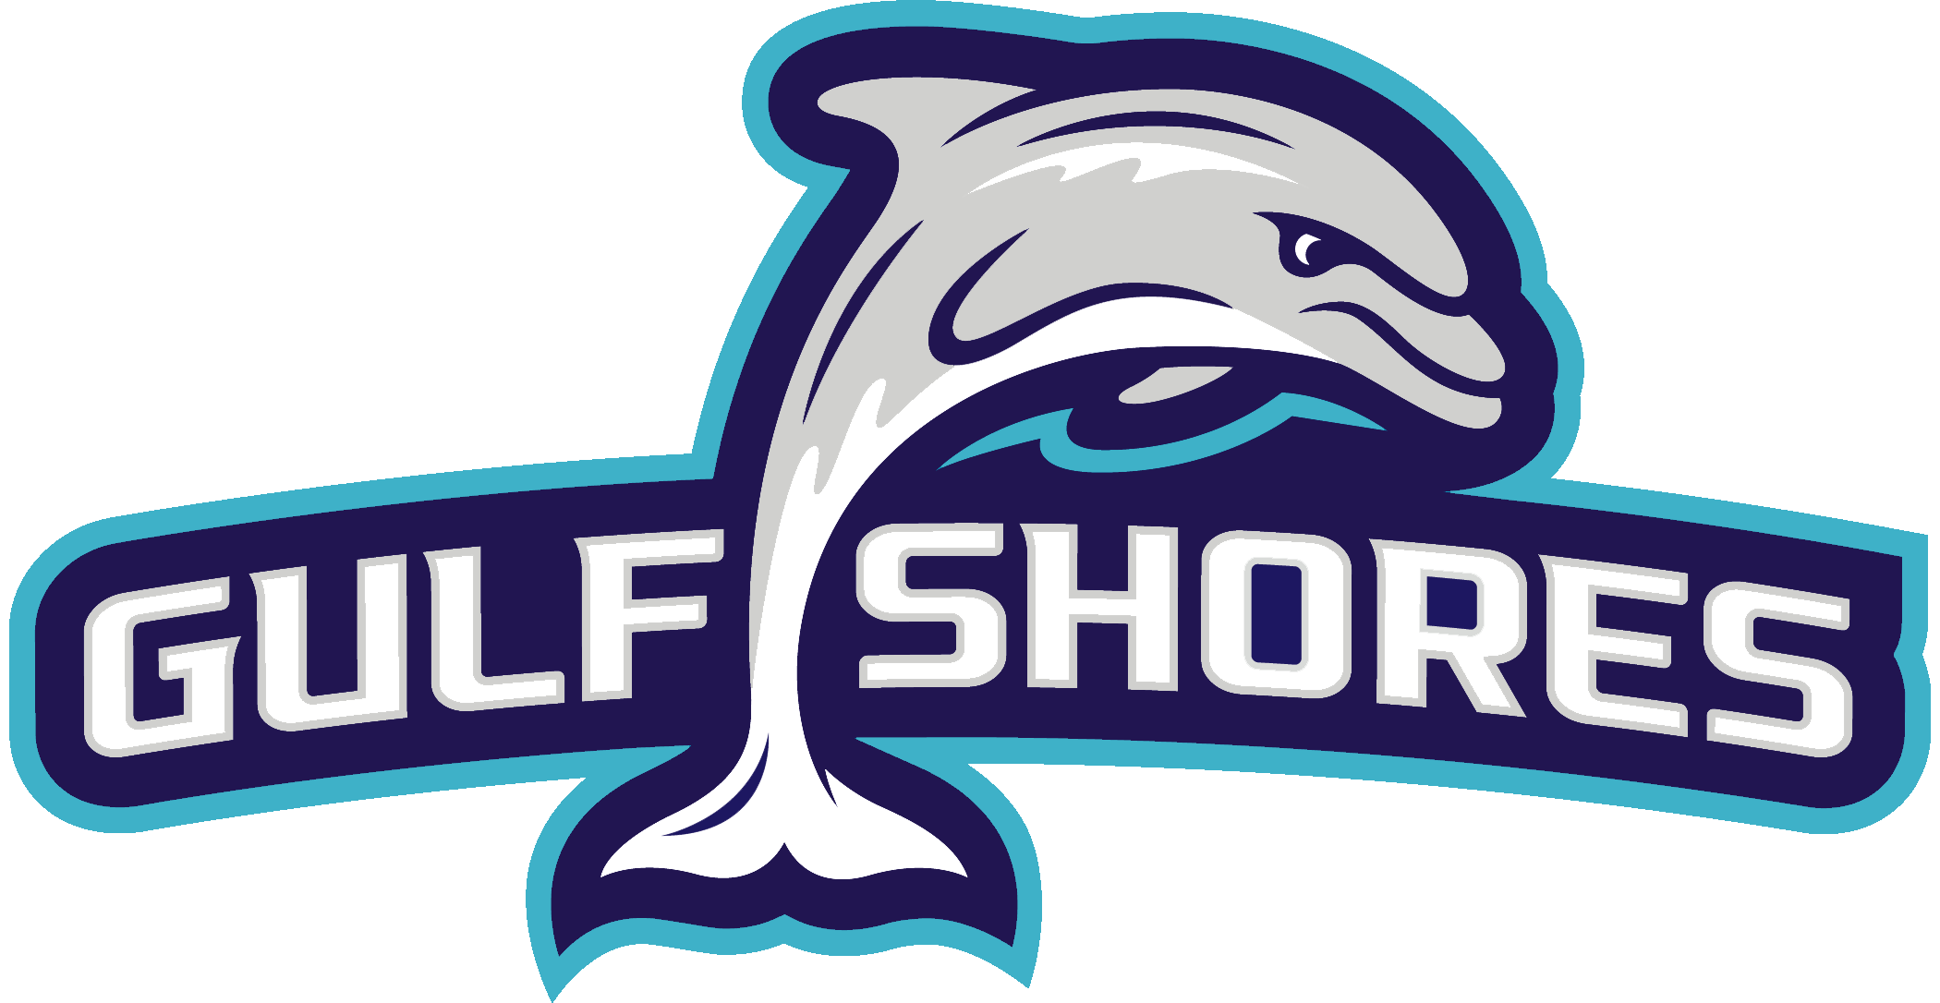

Coaches, Gulf Shores High School will be hosting a Varsity Duals Tournament on January 31st – February 1st, 2020. Team Awards will be given to the top 4 teams

Format – Duals Format, pool matches then cross over

When – Friday January 31st & Saturday, February 1st

Where – Gulf Shores High School

Cost - $200 per team

Time – Weigh in Friday 4:00pm-5:00pm Start Wrestling at 5:30pm
Saturday Weigh in 7:00am-8:00am Start Wrestling 9:00am

Admission – $15 Both day Pass
$7 Friday Only
$10 Saturday Only

Hospitality Room – Hospitality room will be provided for coaches, officials, and tournament workers.

Hotel Info: https://www.gulfshores.com/events-calendar/sports-commission-website-event/2020-gshs-wrestling-dolphin-duals/

If you need any further information please contact me, Britt Shaw at bshaw@gulfshorescityschools.org

