GRINDSTONE DUALS 2019
@ Winters Mill High School 560 Gorsuch Rd. Westminster, MD
Friday, Dec. 13:
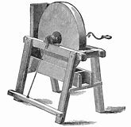
Weigh-ins: 2:30-3:30
Round 1: 4:00-5:30
Round 2: 5:30-7:00
Round 3: 7:00-8:30
Saturday, Dec. 14:
Weigh-ins: 8:00-9:00
Round 4: 9:30-11:00
Round 5: 11:00-12:30
Break: 12:30-1:00
Round 6: 1:00-2:30
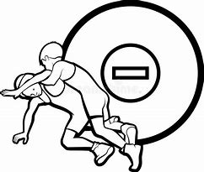
Round 7: 2:30-4:00 p.m.
TEAMS:
- Winters Mill
- Landsdowne
- Broadneck
- Liberty
- Leonardtown
- Old Mill
- Howard
SCHEDULE & MAT ASSIGNMENTS

E
