LOCATION:
Due to new management at Emerald Coast Conference Center, I was unable to secure it this year. We will be hosting the tournament at Fort Walton Beach High School. Last year’s input from coaches, we will have 3 mats in the gym and 3 in the cafeteria. By doing this each area will have increased viewing for spectators and better wrestling areas for teams. and it is less than one minute from each other.
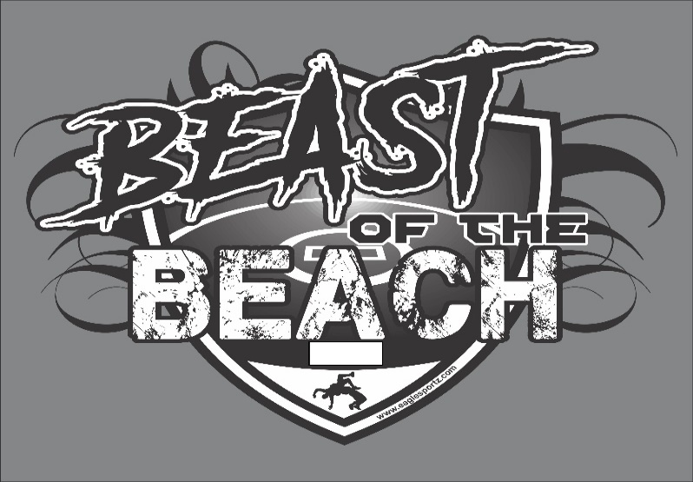

WEIGH-INS:
Friday AM Pool- 8:00 am
Friday PM Pool-2:00 pm
SATURDAY-8:00 am ALL TEAMS
WRESTLING BEGINS AT 9:00 am both days
Friday PM Pools 3:00 pm

COST:
$400.00
Make checks Payable to:
FWBHS WRESTLING
400 HOLLYWOOD BLVD SW
FORT WALTON BEACH, FL. 32548

ADMISSION FEE:
10.00 FOR ADULTS

HOST HOTEL
The Island (was Ramada)

IF YOU HAVE ANY QUESTIONS PLEASE CONTACT TOBI MAREZ
850-420-0111 OR EMAIL TOBI.MAREZ@OKALOOSASCHOOLS.COM

