8th Annual Tricounty Invitational
Powered by BSN Sports
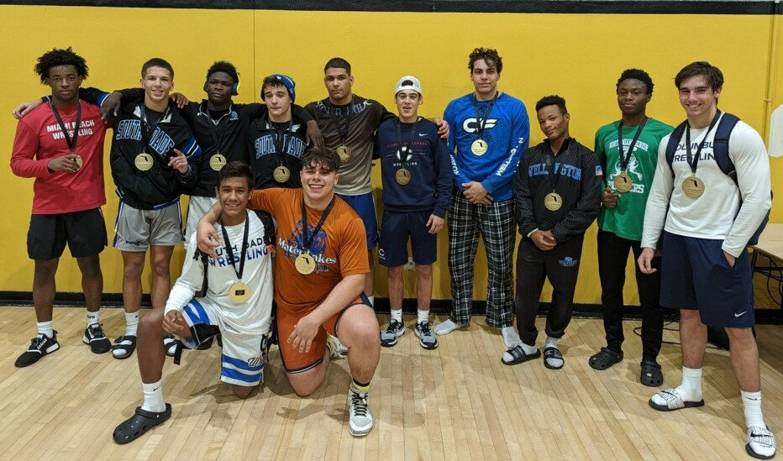
IBT - TOURNAMENT INFORMATION
HOST: Olympic Heights High School
20101 Lyons Road
Boca Raton, FL 33434

ROSTERS DUE: Wednesday, January 25@7pm to Coach Mears: leevy.mears@palmbeachschools.org
An email will be sent out Thursday with the top 4 seeds. If you won a head to head or have a change/concern, email it and we will make the adjustment.

DATES OF TOURNAMENT: Friday, Jan 27th & Saturday, January 28th, 2023

WEIGH-IN: Friday – 11am
Coaches’ Scratch Meeting Friday: Noon
Saturday – 9:00am

WRESTLING BEGINS: Friday – 1:00pm (thru championship quarterfinals & 3 rounds of consolations)
Saturday – 11am – beginning with semi-finals (finals will be tentatively 5pm)

HOSPITALITY ROOM: Friday – 4:30pm—6pm
Saturday – 8am—9:30am & Noon-1:30pm

ENTRY FEE: $350 to Olympic Heights Wrestling by October 1st, $375 by Nov 1st, $400 by Dec 1st, payment day of tournament will be $450

Year Champions Runner-up____ 3rd Place
2015 Southwest Miami 268.50 Olympic Heights 203.50 Tie Cypress Bay/North Miami 161.0
2016 Olympic Heights 256.50 Southwest Miami 236.0 Cypress Bay 201.0
2017 Southwest Miami 283 Wellington 180.5 Olympic Heights 175.0
2018 Fleming Island 282.5 Columbus 182.5 Southwest Miami 178.0
2019 South Dade 251.5 Fleming Island 238 Southwest Miami 234.0
2020 South Dade 327.5 Southwest Miami 218.0 Hagerty 191.0
2021 Cancelled Covid-19 ----------------- ------------------
2022 South Dade 309.5 Columbus 224.5 Mater Lakes 187.5
2023 Who’s next

Confirmed for 2022//2023
1. Olympic Heights 13. Doral Academy 25. North Miami
2. Miami Norland 14. Ferguson 26. Columbus
3. Dwyer 15. Miami Beach 27. Treasure Coast
4. Jupiter Christian 16. Southridge 28. South Dade
5. Lincoln Park Academy 17. Barbara Goleman 29. Wellington
6. Park Vista 18. Palm Beach Gardens
7. St Andrews 19. Atlantic
8. Miami Palmetto 20. Braddock Bold = Paid
9. Royal Palm Beach 21. Dr Krop
10.South Fork 22. Westminster Christian
11. Seminole Ridge 23. Lincoln Park Academy
12. Columbus 24. Fort Pierce Central

Hotel Accommodations
Holiday Inn-Express Boca Raton-West Hilton Boca Raton Suites
8144 Glades Rd 7920 Glades Rd
Boca Raton, FL 33434 Boca Raton, FL 33434
(561)482-7070 (561) 483-3600
5 minutes from school 5 minutes from school

Contact Info: Leevy Mears (563) 580-9472
Leevy.Mears@palmbeachschools.org

Individual Champions by Year
Wgt 2015 2016 2017 2018
106 Radli(Jup) Silvestre(HH) DiFiore(Well) Gagliardo(FI)
113 Gonzalez(SW) Abramson(Well) Hernandez(SW) Jackson(FI)
120 Wigley(OH) Farr(SemR) Godinez(HML) Godinez(HML)
126 Valdes(SW) Valdes(SW) Abramson(Well) Melguizo(Col)
132 Urquiza(SW) Urquiza(SW) Urquiza(SW) Hernandez(SW)
138 Delcueto(SW) Acedo(SW) Valdes(SW) Urguiza(SW)
145 Gillis(ABM) Delcueto(SW) Pidgeon(PBG) Townsend(Well)
152 Moselund(PBG) Smiley(SemR) Lentz(WB) Wilson(Pal)
160 Kosoy(OH) LaPeter(SemR) Vidaud(SW) Vidaud(SW)
170 Dolorit(SW) Kosoy(OH) Delcueto(SW) Detwiler(FI)
182 Sotolongo(SW) Eisman(CB) Loy(FH) Singletary(PR)
195 Castro(OH) Sotolongo(SW) Barrocas(RR) Bordeau(WB)
220 Macugoski(CC) Castro(OH) Schwartzberg(ML) Smenda(FI)
285 Escoto(San) Jiovenetta(CShores) Earle(FH) Higgins(JC)

Wgt 2019 2020 2021 2022
106 Rowland(Hag) Morales(SD) Cancelled Vazquez(Dor)
113 VanHoeke(PR) Martinez(SW) Covid-19 Jones(Well)
120 Melguizo(SW) Shaw(Hag) Guzman(Col)
126 Orta(SD) Melguizo(SW) Exalent(NM)
132 Reyna(SD) Neco(SD) Solis(SD)
138 Swan(SD) Tal Shahar(AHD) Sanchez(Dor)
145 Hernandez(SW) Temes(ML) Balmeceda(SD)
152 Villalobos(CP) Swan(SD) Couto(SD)
160 Balmeceda(SD) Villalobos(SD) White(SD)
170 Valdes(SW) Vidaud(SW) Forbes(MB)
182 Vidaud(SW) Lopez(Hag) Taylor(Col)
195 Singletary(PR) Marshall(MSR) Cervantes(SD)
220 Canedo(PBG) Thompson(AHD) Ricardo(Well)
285 DiPrima(OH) Saul(OH) Vergara(ML)

Wgt 2023

106 Your name?

THANK YOU TO OUR SPONSORS

