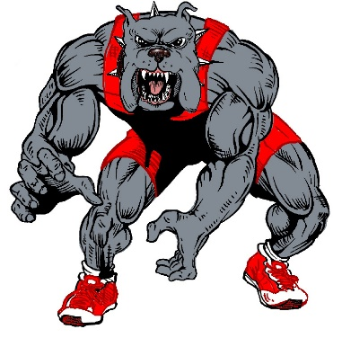
Bulldog Brawl
November 19, 2022
Fontainebleau High School

Format: The brackets will be 8, 10, or 12 man scramble type brackets. For any weight classes with fewer than 7 wrestlers, a round robin bracket will be used. A breakdown of a 10 man scramble is on page two of this flyer.

Entries: There will be a maximum of 12 wrestlers per weight class. Coaches are encouraged to submit JV entries, and each coach will be notified by email which wrestlers made it into the tournament on Thursday night. Preference is given to Varsity wrestlers, then to teams with the earliest entries. Entries will be entered on Trackwrestling.

Weigh-ins: Weigh-ins will be by team at 8:00 AM in the gym. Wrestling will begin as close to 9:00 as possible.

Fee: $10 per wrestler. Cash or check made payable to “Fontainebleau High School.”

Awards: 1st – 3rd place in each weight class earn medals. Champions of each weight class are awarded a hoodie. There is also an Outstanding Wrestler voted by coaches and the Paul Fradella Sportsmanship award voted by referees.

BULLDOG BRAWL FORMAT
Black Pool Red Pool Weight Class ###
- 6
- 7
- 8
- 9
- 10

1st Round: 1 vs 2 3 vs 4 5 Bye 6 vs 7 8 vs 9 10 Bye
2nd Round: 1 vs 3 2 vs 5 4 Bye 6 vs 8 7 vs 10 9 Bye
3rd Round: 1 vs 5 2 vs 4 3 Bye 6 vs 10 7 vs 9 8 Bye
4th Round: 1 vs 4 3vs 5 2 Bye 6 vs 9 8 vs 10 7 Bye
5th Round: 2 vs 3 4 vs 5 1 Bye 7 vs 8 9 vs 10 6 Bye

Winner Black vs Winner Red
Black 2nd vs Red 2nd
Black 3rd vs Red 3rd
Black 4th vs Red 4th
Black 5th vs Red 5th

