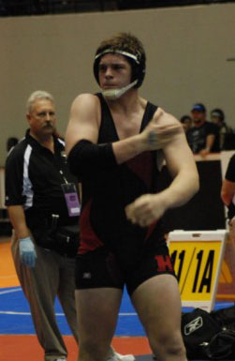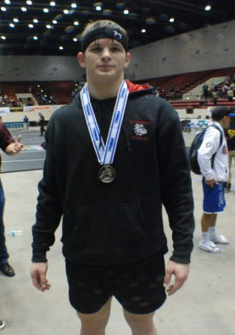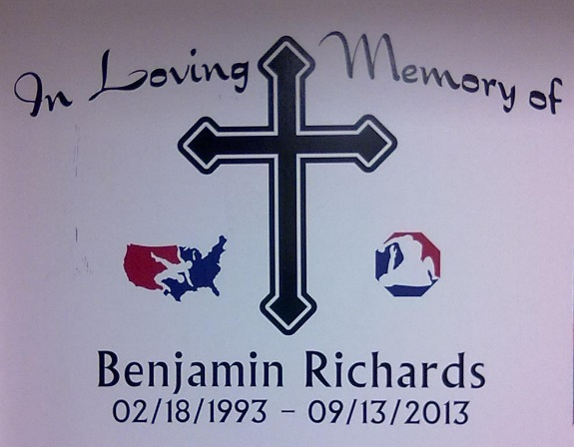
4th Annual Ben Richards Memorial
Host: Leto High School: Tournament Venue River Ridge High School
(11646 Town Center Rd, New Port Richey, FL 34654)
Date: December 4, 2021
Format: 20 Team IBT
Weigh-ins: 8:30 am
Wrestling starts: at 9:30 am
This tournament is open to the first 20 teams that contact me.
The cost is $300. (Make checks to: Leto HS Booster Club with Wrestling in the memo)
IBT with 5 placers and an OW for light and heavy weight.

Teams: Berkeley Prep, Bloomingdale, Chamberlain, Clearwater Central Catholic, Evans, Gaither, Jesuit, Lennard, Leto, Palmetto, Plant City, River Ridge, Riverview, Riverview Sarasota, Robinson, Steinbrenner, Strawberry Crest

Thank You for your Support
Mike Patrick
Head Wrestling Coach
Leto High School
4409 W. Sligh Ave.
Tampa, FL 33614
Cell # 813-361-6469

