Douglas County Tiara Challenge January 22, 2022
The tournament will be held in the Douglas County High School Main Gym (2842 Front Street, Castle Rock, CO 80104). The schedule will be as follows:
Saturday, January 22, 2022 – Girls Varsity and Junior Varsity
Weigh-In 7:00 a.m.
Coaches Meeting After weigh-ins conclude
Start Wrestling 8:30 a.m.
*All participants must be certified eligible according to the rules of the Colorado High School Activities Association.
Admission prices will be as follows:
All Day:
Adults $10.00
Students $4.00
Seniors $4.00
Children in 5th Grade and under are FREE!
*Concession stand will be available.
A trophy will be awarded to the team champion for the Varsity tournament. ● Tiara’s will be awarded to 1st place in Varsity brackets
*All athletes and spectators are responsible for their own belongings.
Team Entry Fees are as follows:
- $250 per team (or co-op district team) to include both V and JV wrestlers - $25 per wrestler for teams with 6 or fewer athletes
- **TEAM ENTRY FEE must be paid prior to weigh-ins / If your team has not paid they will NOT be allowed to weigh in!**
*We will use Track Wrestling to seed the tournament. Seeds will be confirmed in the coaches’ meeting.
Criteria will be based on the current season and any previous State placing from ‘21 season and ‘19-’20 season (seasons since Girls Wrestling became sanctioned).
● 16 women brackets will be used for all Varsity brackets. (bracket breakdown attached).
○ For weights with less than 16 wrestlers, the most appropriate bracket style will be used to ensure the maximum amount of matched (up to 5) for each wrestler.
○ Round Robin brackets will be used for weight classes with 6 or fewer wrestlers.
○ Junior Varsity brackets will be created based on numbers with the intent to give girls the most amount of matches ( Round Robin in brackets of 6).
Douglas County Tiara Challenge January 22, 2022
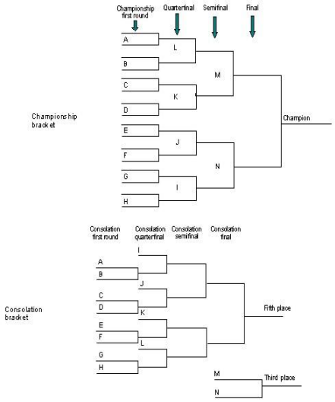
Douglas County Tiara Challenge January 22, 2022
Dear Athletic Director & Coach:
The Tiara Challenge Tournament will be held on Saturday, January 22, 2022
Complete the confirmation form below and email back to me by
December 1, 2021. Email and CC to the following:
prrademacher@dcsdk12.org
jshawcroft1@dcsdk12.org
jlgardella@dcsdk12.org
Respectfully,
Jeff Gardella
Athletic Director
~~~~~~~~~~~~~~~~~~~~~~~~~~~~~~~~~~~~~~~~~~~~~~~~~~~~~~~~~~~~~~~
____________ High School will attend the Douglas County High School’s Tiara Challenge on Saturday, January 22, 20222. Entry Fee $250 per team or $25 per wrestler for teams with 6 or fewer
Please mail a check prior to January 1st, 2022 (or bring money to weigh-ins).
Douglas County Wrestling
2842 Front Street, Castle Rock, CO 80104
Athletic Director ____________________________________________________ Coach____________________________________________________________ Best Phone Number ________________________________________________ Email address_____________________________________________________

