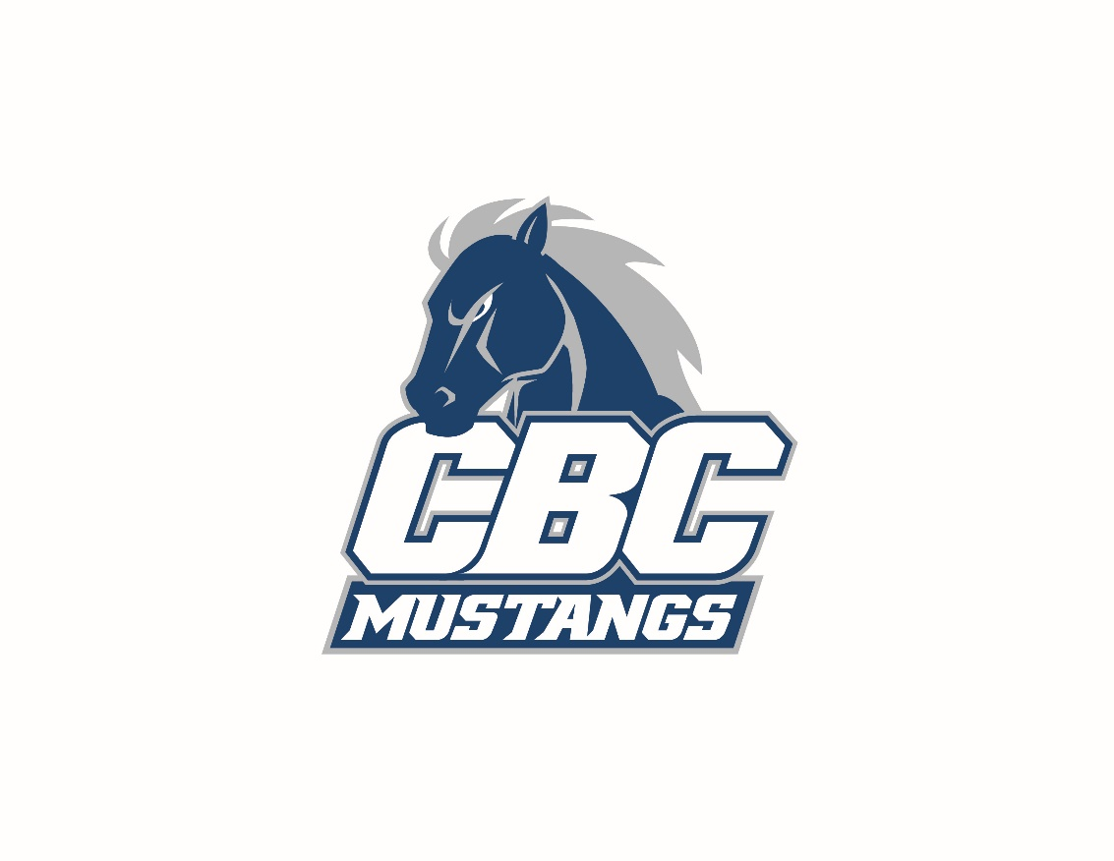
Mustang Invitational
Conway, Arkansas

Date: Saturday January 15th, 2022.

Place: A.R. Reddin Fieldhouse
1501 College Ave.
Conway, AR 72034

Weigh-Ins Skin Check 6:45AM Weigh-in @ 7am.

Weight Classes: 125, 133, 141, 149, 157, 165, 174, 184, 197 and 285.

Entry Fee: A fee of $400 per team will be charged. Entry fee must be paid prior to weigh in!!! Wrestlers will not be allowed to weigh in without payment. Entry fee is non-refundable.

Tournament: This will be a double elimination format tournament. Place top 4 individual in each weight class. Top three teams will receive team trophy.

Timing: All matches will be 7 minutes with riding time. If the match is tied, the NCAA overtime procedure will be used.

SCORING: There will be team scoring. Each team is ONLY allowed up to 12
wrestlers and all 12 wrestlers will cumulate team points
throughout the tournament.

Matches: Wrestling will start at 9AM. and run through Track Wrestling.

Seeding: Seeding Meeting will be Friday January 14th 7:00pm in the Community Room located on the CBC Campus. NAIA national seeding criteria will be used for seeding.

Awards: Team Trophy will be awarded to the top three teams of the invitational. Top three placer per weight class will receive a medal.

Entry Deadline: All entries must be submitted by Thursday January 13th 5:00pm. This tournament will be run through Track wrestling and will require you to import you’re roster through the OPC.

Director: Ken Prophete, Head Wrestling Coach, Central Baptist College
Email: kprophete@cbc.edu, Office: 501.205.8846. Cell: 501.548.9915
Lodging: For more information on lodging just email me for the list of hotels.

2021 Participants

Central Baptist College
Oklahoma Wesleyan Uni.
Williams Baptist Uni.
Brewton-Parker College
Texas Wesleyan University (3rd Place)
Life University (2nd Place)
Cumberland University
Grandview University (1st Place)
2022 Committed Participants
- Central Baptist College: Coach Prophete (Committed January 10th)
- Ouachita Baptist University: Coach Kevin Crutchmer (Committed May 1st)
- Oklahoma Wesleyan University: Coach Tom Carr (Committed April 27th)
- Texas Wesleyan University Coach Ray Bedford (Committed Jan. 2nd)
- Midway College Coach Jake Brumbelow (Committed April 4th)
- Brewton Parker College Coach Tim Mitchell (Committed May 10th)
- Oklahoma City University Coach Justin Ensign (Committed Oct.)
- Hannibal LaGrange University Coach Dan Capp (Committed. Aug,)
- William Baptist University Coach Tyler Fraley (Committed May)
- University of the Ozarks Coach LeRoy Gardner (Committed June)

