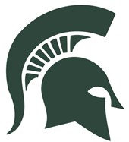
2021 Spartan Invitational
Dates: December 10th/11th, 2020
This will be a traditional tournament. The tournament will be ran on 6 mats until the final round.
Entry: $250 per team, make check payable to MBHS Wrestling
-$7 each additional wrestler
Weigh-ins: Weigh-in will begin at MBHS Spartan Arena at 3:30-5pm Friday. Weigh-in Saturday at 7:30am.
Awards: Individual- 1st, 2nd, 3rd, and 4th
Team- 1st, 2nd, and 3rd
Seeding: Will be done through track wrestling, if you are an out of state team I will need your lineups and seeding information by Thursday @ 5:00.
Wrestling Sessions: Friday, Goal is to start wrestling by 5:45. Saturday to begin the first round to start at 9:00 a.m. We will wrestle to completion. In the past, we have been completed around 9:30 on Friday and 1:30 on Saturday.
**Hospitality Room will be available for coaches. Email your confirmation upon receipt of this information!!!
Justin Ransom
RansomJ@MtnBrook.k12.al.us
678-409-8425

