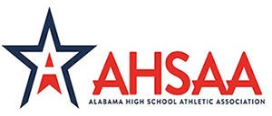

2021 OFFICIALS CLINIC TOURNAMENT
DATE: June 26, 2021
LOCATION: Spain Park High School
FORMAT: This will be an individual tournament. RR/Scrambles
WEIGH CLASSES: Standard weight classes +2 pounds
Girls Division if enough interest.
Boys: 106/113…
Girls: 95,105,115,120,130,140,150,165,185,225,285
ENTRY: $200 per team or $10 per wrestler. Make check payable to SPHS Wrestling.
$10 for fans
WEIGH-INS: Weigh-in will begin at Spain Park HS at 7:00 – 8:00am.
Start Wrestling 9:00am.
SEEDING: Basic Criteria/Blind draw.
REGISTRATION: Coaches will be sent TW link in advanced. Enter wrestlers as normal.

If you would like your team to attend, please email Eric Pollard below.
CONTACT:
Eric Pollard
Tournament Director
epollard@pelhamcityschools.org
256-603-4084

