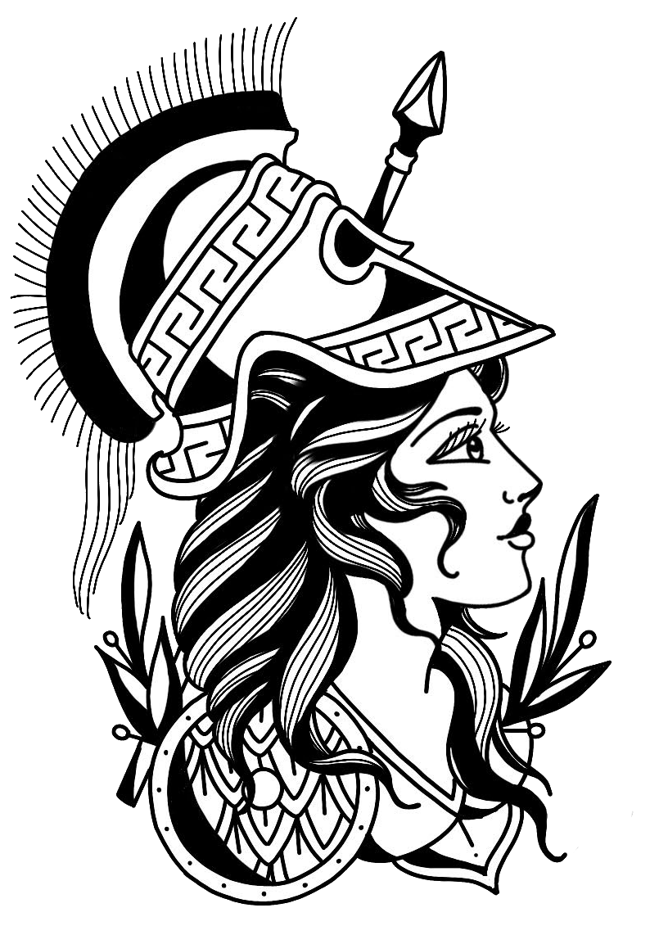  18th Annual Castro Valley  Girls Wrestling  Classic  When  December 19TH 2020  6am- Doors open  7am- Weigh ins  9am- Wrestling begins  Where  Castro Valley  High School  19400 Santa Maria Ave,  Castro Valley CA  Eligibility: Any female wrestler in good standing with her high school in accordance with CIF rules.  Weight Classes: 101, 106, 111, 116, 121, 126, 131, 137, 143, 150, 160, 170, 189, 235  Awards: Medals to top 6 in each weight class, banners for top 3 teams, OW award to low, middle and upper weight classes.Crowns to Champions for Varsity Winner. Junior Varsity Winner on bracket will receive Medal.  ****All CIF rules and CIF code of conduct will followed and enforced. Tobacco, alcohol, and drugs will be prohibited from this event. Profanity or inappropriate conduct will be cause for ejection from the event and from the campus**** | varsity  and jv tournament  double elimination  entry fee  $30 per wrestler  $300 per team*  (up to 14 wrestlers)  *additional wrestler-$15  ** Fee includes coaches lunch up to 2 coaches and stat person  **ALL TEAMS/WRESTLERS MUST BE PRE-REGISTERED THROUGH TRACK WRESTLING BY THURSDAY, December 17TH @ 12 MIDNIGHT. THERE WILL BE NO WALK-UPS ALLOWED, NO EXCEPTIONS!!!**  ***All SEEDING WILL BE DONE PRIOR THE TOURNAMENT, THROUGH TRACK WRESTLING, COACHES WILL HAVE UNTIL FRIDAY, DECEMBER 18TH TO ENTER WRESTERS STAT INFORMATION.  Email complete entry forms.  Checks must be payable to “CASTRO VALLEY HIGH SCHOOL GIRLS WRESTLING” to:  Castro Valley High School  c/o Sabrina Ross, Wrestling Coach 19400 Santa Maria Ave. Castro Valley, CA 94546  Tournament Directors Contact Information:  Coach Sabrina Ross  Cell # (707) 334-7399  ( text or call )  Email: S.Ross707@gmail.com or sabrina.ross@cv.k12.ca.us.

Please return this portion of this form is you plan on attending.
18th Annual Castro Valley Girls Wrestling
____________________________ ____________________________
School Coach Name
____________________________ _________________________
Email Address Phone Number
- Full Varsity
- Full Varsity with JV wrestlers ___________
- Full JV only # of JV wrestlers
- Individual Varsity
- Individual JV ________________
# of Varsity Wrestlers

