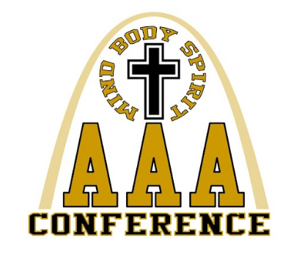
2020 AAA Conference Wrestling Tournament

WRESTLING COACHES/ ATHLETIC DIRECTORS OF:

Bishop DuBourg, Christian O’Fallon, Father Tolton,
Lutheran St. Charles, St. Francis Borgia, St. Mary’s

EVENT: 2020 AAA Conference Wrestling Tournament

LOCATION: St. Mary’s High School
4701 South Grand Blvd
St. Louis, MO 63111

DATE: Saturday January 25, 2020

TIME: Weigh-ins: 9:00am
Wrestling begins: 10:00am

FORMAT: Round-robin for all weight classes

SCORING: Team points will be scored as is defaulted in Track Wrestling. This will be scored in tournament format, not as a dual meet format. We intend to wrestle two mats, and will wrestle in rounds – first all 106 matches for round 1, followed by all 113 matches for round 1, etc.

TRACK WRESTLING: We will be using Trackwrestling.com to run the wrestling tournament. You must enter your wrestlers by 11:00AM on Thursday, January 23. You must submit your seed information by 10:00PM on Friday, January 24. If you want your wrestler to have a seed you must put information into track wrestling.

ADMISSION: $5.00

FACILITIES: Showers are available. All teams will dress in the locker rooms. Secure your own valuables. There are lockers available if you choose to bring a lock. St. Mary’s is not responsible for lost or stolen items.

AWARDS: Team plaque awarded to 1st place team.
Individual Medals for top 3 in each weight class.

OFFICIALS: Martin Linson – Head Official, Rodney Powell, Mark Kristoff

HOSPITALITY ROOM: For coaches, administrators, tournament staff, and bus drivers only.

TOURNAMENT DIRECTOR: Chris Colona - colonac@stmaryshs.com
Any questions, please contact Chris via email or phone 636-751-0790.

*** THERE WILL BE A CONCESSION STAND ***

