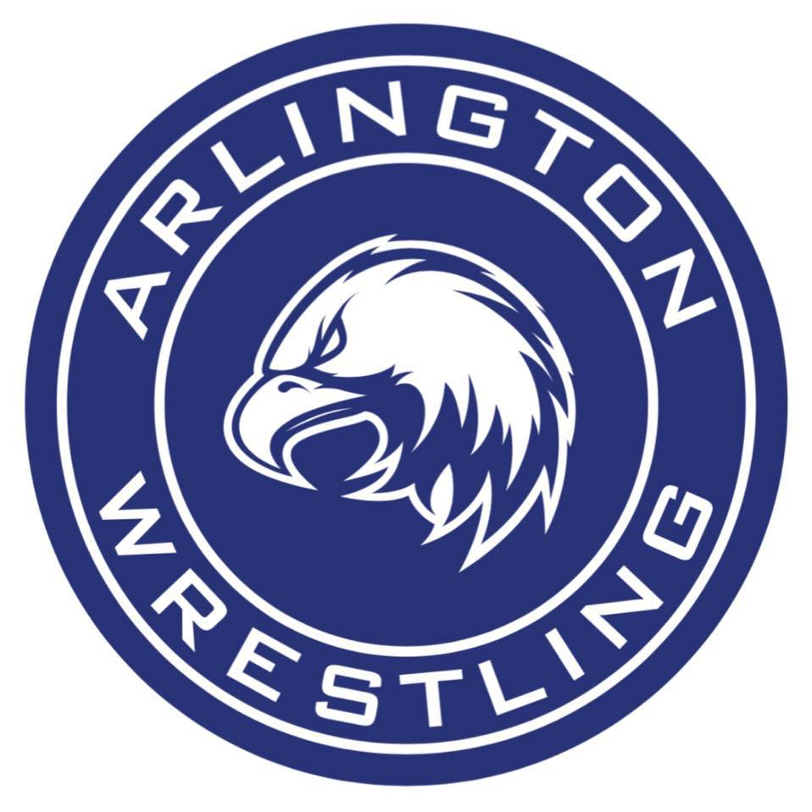 |  | 2020 Arlington  Boys JV Rumble  Wrestling Tournament |  | Tournament Director  Ben Mendro  Head Coach  Jonny Gilbertson  Assistants  Gary Niklason  Kenny Sanders
 |  | Fact Sheet
Date: | Saturday, January 18th, 2020
Times: | Weigh-in: |  | 8:00AM
 | Coaches’ meeting: |  | 9:30AM
 | Wrestling starts: |  | 10:00AM
Entry Fee: | $225 per team if payment received by 1/10/20
 | $250 per team if payment received after that date
 | (unlimited numbers) – non-refundable
 | Send checks payable to: |  | Arlington High Athletics
c/o Meaghan Rust-Matter,
Athletic Secretary
 |  |  | 18821 Crown Ridge Blvd.
 |  |  | Arlington, WA 98223
Roster: | Please email your tentative roster to Ben Mendro,  at bmendro@asd.wednet.edu by Wednesday, January 8th
Admission: | $6 adults $3 Students w/ASB $3 Children/Seniors
Details: | - Eight-man brackets  - Three matches guaranteed  - All matches: 2-1-1 with sudden death if required  - Ribbons for top 4 finishers in each 8-man bracket
*Please note that in years past there has been a separate girls division. This year, there will not be. If you have a handful of girls you want to bring, they will wrestle in the boys division with no special accommodations to special girls brackets. Our girls’ team will host a separate tournament on 1/11/20. if interested, please reach out to Jim Smoots at: jsmoots@asd.wednet.edu

Any questions or concerns, email Coach Gilbertson at ahsgilbertson@gmail.com or
Ben Mendro at bmendro@asd.wednet.edu

