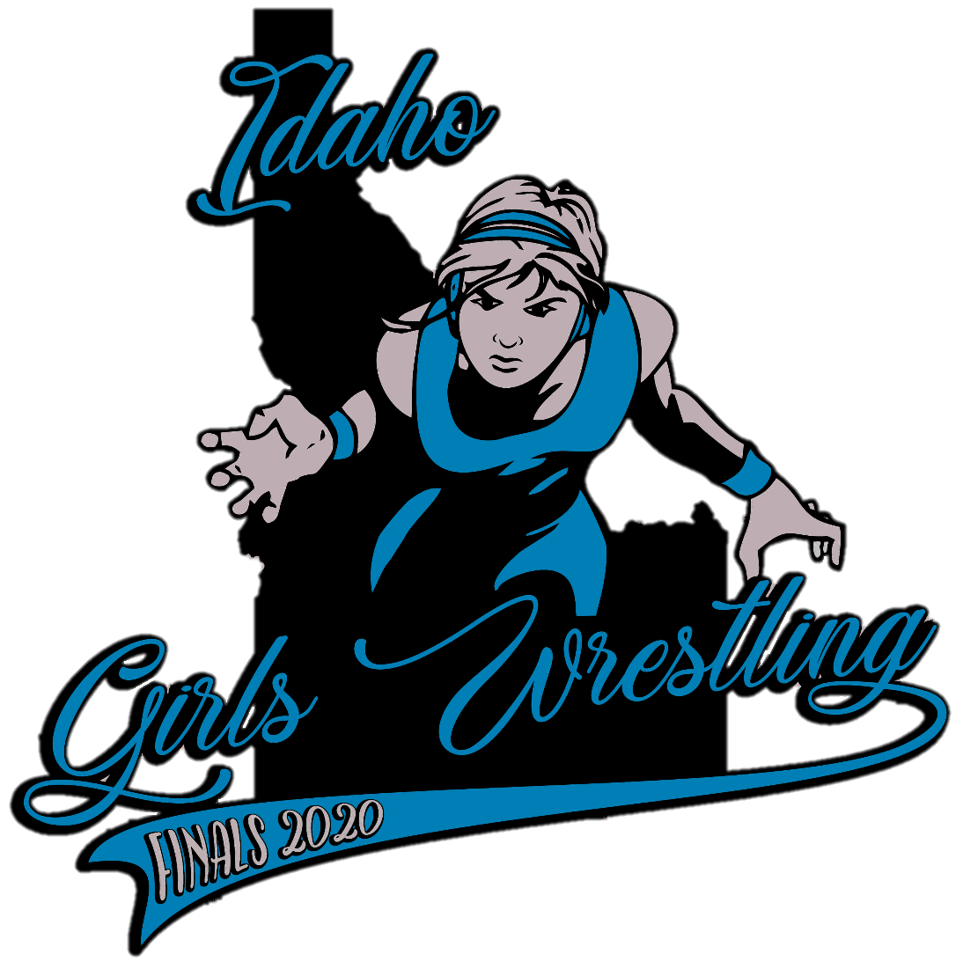
Pocatello High School is again host to the 2nd annual Idaho Girls Wrestling Finals tournament Feb 15, 2020. Tournament is free to all Idaho High School girl wrestlers, no entry fee! All girl wrestling participants will receive an Idaho Girls Wrestling Championship hoodie, Championship medals 1st through 6th place, & Team trophies for 1st, 2nd, 3rd place. Weights will be our Idaho Women’s Wrestling Committee’s proposed weights of 100, 106, 112, 120, 129, 138, 148, 159, 170, 191, 235/285 +2 lbs for weigh ins, and weights may be combined to fill brackets for a true championship. Weigh ins are at 8am, followed by a short coaches meeting, and wrestling will begin at 10am.

Coaches & ADs, please make sure you talk with your wrestlers in order to save this date from their 15 dates allowed. Motel 6 in Chubbuck has agreed to save a block of rooms @$45.99 for traveling wrestlers & teams. If you have any questions or need other accommodations, please contact the following directors. Thanks & hope to see you here! #IGNITE
JB Plato Jordan Johns Teresa Praska
Tournament Director Tournament Director Tournament Manager
208-760-0447 208-251-8147 208-705-5615
johnbplato@yahoo.com Jordo327@gmail.com teresa@avcenter.com

PROUD SPONSOR

