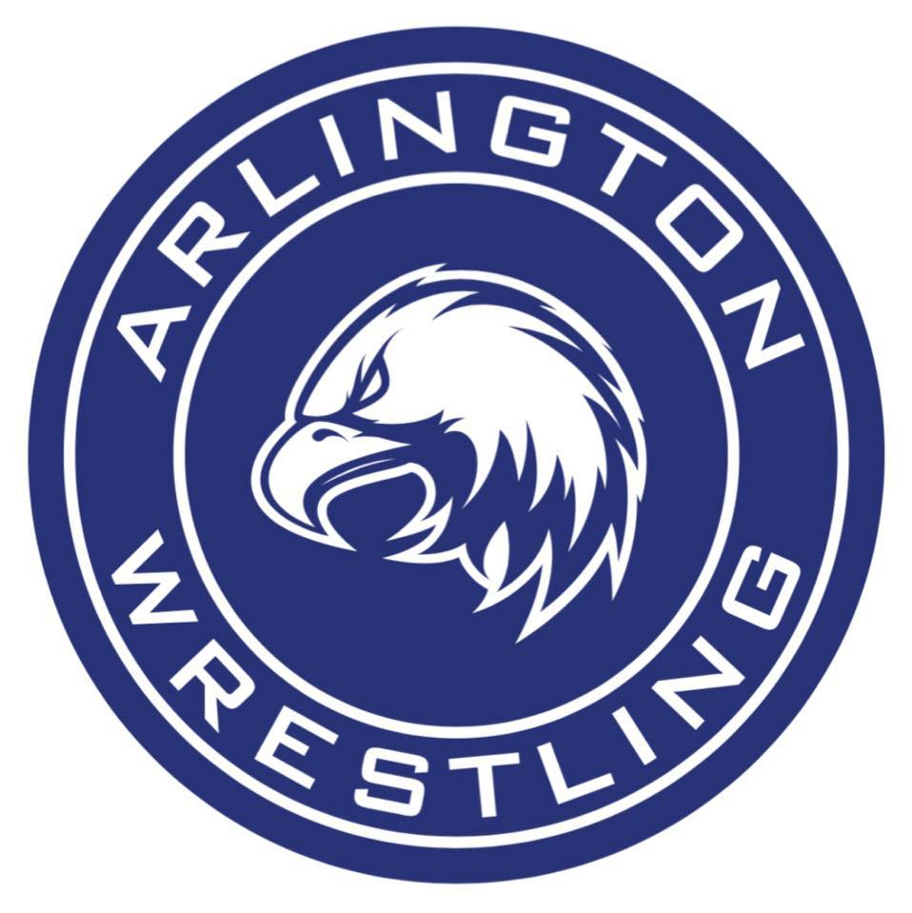 |  | 2019  A-Town Throwdown  Varsity Tournament |  | Tournament Director:  Ben Mendro  Head Coach  Jonny Gilbertson  Assistant Coaches:  Gary Niklason  Kenny Sanders
 |  | Fact Sheet
Date and Place: | Saturday, December 14th, 2019  Arlington High School  18821 Crown Ridge Blvd.  Arlington WA, 98223
Times: | Weigh-in: |  | 8:00AM
 | Coaches’ meeting: |  | 9:30AM
 | Wrestling starts: |  | 10:00AM
Entry Fee: | $400 per team if payment received by 12/14/19
 | $425 per team if payment received after that date
 | – non-refundable
 | Send checks payable to: |  | Arlington High Athletics
c/o Meaghan Rust-Matter,
Athletic Secretary
 |  |  | 18821 Crown Ridge Blvd.
 |  |  | Arlington, WA 98223
Roster: | Please email your tentative roster to Ben Mendro,  at bmendro@asd.wednet.edu by Wednesday, December 11th at 3:30pm
Admission: | $6 adults $3 Students w/ASB $3 Children/Seniors
Details: | - Each school may bring 2 entries per weight  - 16-man brackets  - Potential pigtails, if required, per weight  - Medals for top 3 finishers in each bracket  - Team Trophy for the winning team  - Team Scoring – Traditional scoring will be used. All entries are point scorers.  - If any team has a match scheduled for December 13th, please notify at least 24 hours in advance.
Questions? Email Coach Gilbertson at ahsgilbertson@gmail.com, or Ben Mendro at bmendro@asd.wednet.edu
A-Town Throwdown December 14th, 2019
PLEASE FILL OUT SEEDING INFORMATION and EMAIL to
Ben Mendro: bmendro@asd.wednet.edu
BOYS VARSITY TOURNAMENT
School :

Weight | Wrestler Name | Grade | State '19 | Regionals '19 | Districts '19 | Previous Season Record / Notes
106 #1
106 #2
113 #1
113 #2
120 #1
120 #2
126 #1
126 #2
132 #1
132 #2
138 #1
138 #2
145 #1
145 #2
152 #1
152 #2
160 #1
160 #2
170 #1
170 #2
182 #1
182 #2
195 #1
195 #2
220 #1
220 #2
285 #1
285 #2

2018 A-TOWN THROWDOWN WRESTLING TOURNAMENT

Pass List
School:

Address:

Coaches & Managers:

Managers:

Coach’s Phone Number:

Coach’s email:

Cheerleaders in uniform will be admitted free.

