Gorilla Warfare VI
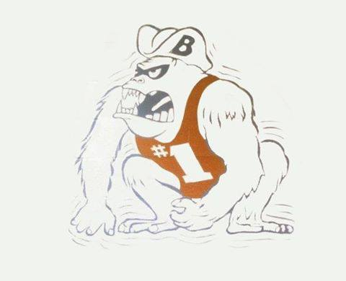
When: December 20-21 2019
Where: Berkmar High School
405 Pleasant Hill Road
Lilburn, GA 30047

Admission: $12 for Friday and Saturday;
$7 single day admission

Time: 4:30 p.m. on Friday
9:00 AM Start Saturday

Weigh Ins: 2:30 p.m.-3:30 p.m. Friday
7:00 AM Saturday

Cost: $200 for JV (first 16 teams)
$250 for V
$400 for Both make checks out to Berkmar HS Takedown Club

Varsity Format: varsity run on track, seeding criteria head to head, state champ, state placer, state qualifier, sectional qualifier, common opponent, common sense

JV Format: scramble Saturday only

Awards: Top 3 Teams (V) receive trophies, and varsity individual medals top four

