2019 “UD Invitational” at the University of Dubuque
The University of Dubuque is pleased to host the “UD Invitational” wrestling tournament. The tournament will be held on Saturday, November 16th, 2019.
We will use the same Trackwrestling score clocks/computers used at the NCAA Championship, so all match results and statistics will be completed for you. This should also ensure that the event is conducted in a well-run, time efficient manner. The following is the timetable and relevant information for the tournament:
Timeline: Building Opens 5:45a.m.; Coaches confirm/scratch entries upon arrival
- Skin check - 6:45 a.m.
- Weigh-ins – 7:00 a.m.
- Coaches Meeting to Collect Entry Fees/Review Brackets – 7:45 a.m.
- Wrestling begins - 9:00am (we expect to be finished between 2-3:00pm)
Awards:
- Individual awards (t-shirts) for first, second and third place at each weight
- Sling Bags for each entry at weigh-ins from our tournament sponsor
Matches: 3-2-2 in length, all NCAA rules will be followed. This is not an open tournament; all wrestlers must meet NCAA eligibility and be a participating active member of your roster. Placement matches to top 6 per weight. No official team scores kept.
Entries: To be completed online via the OPC/Trackwrestling.com by noon on Thursday, November 9
Fees: $25 per wrestler. Checks payable to UD Wrestling or bring exact cash the day of.
Committed Teams for 2019 Include:
- University of Dubuque
- University of Chicago
- Nebraska Wesleyan
- North Central College
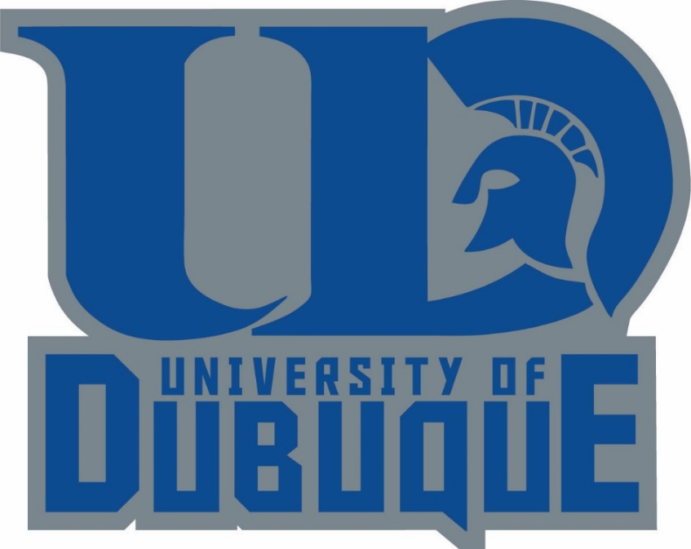
- Westminster

Email Nate Hansen at nhansen@dbq.edu or via phone at (cell) 605-830-0456 if you have any questions. The tournament will be held at the CR Wellness Center.

