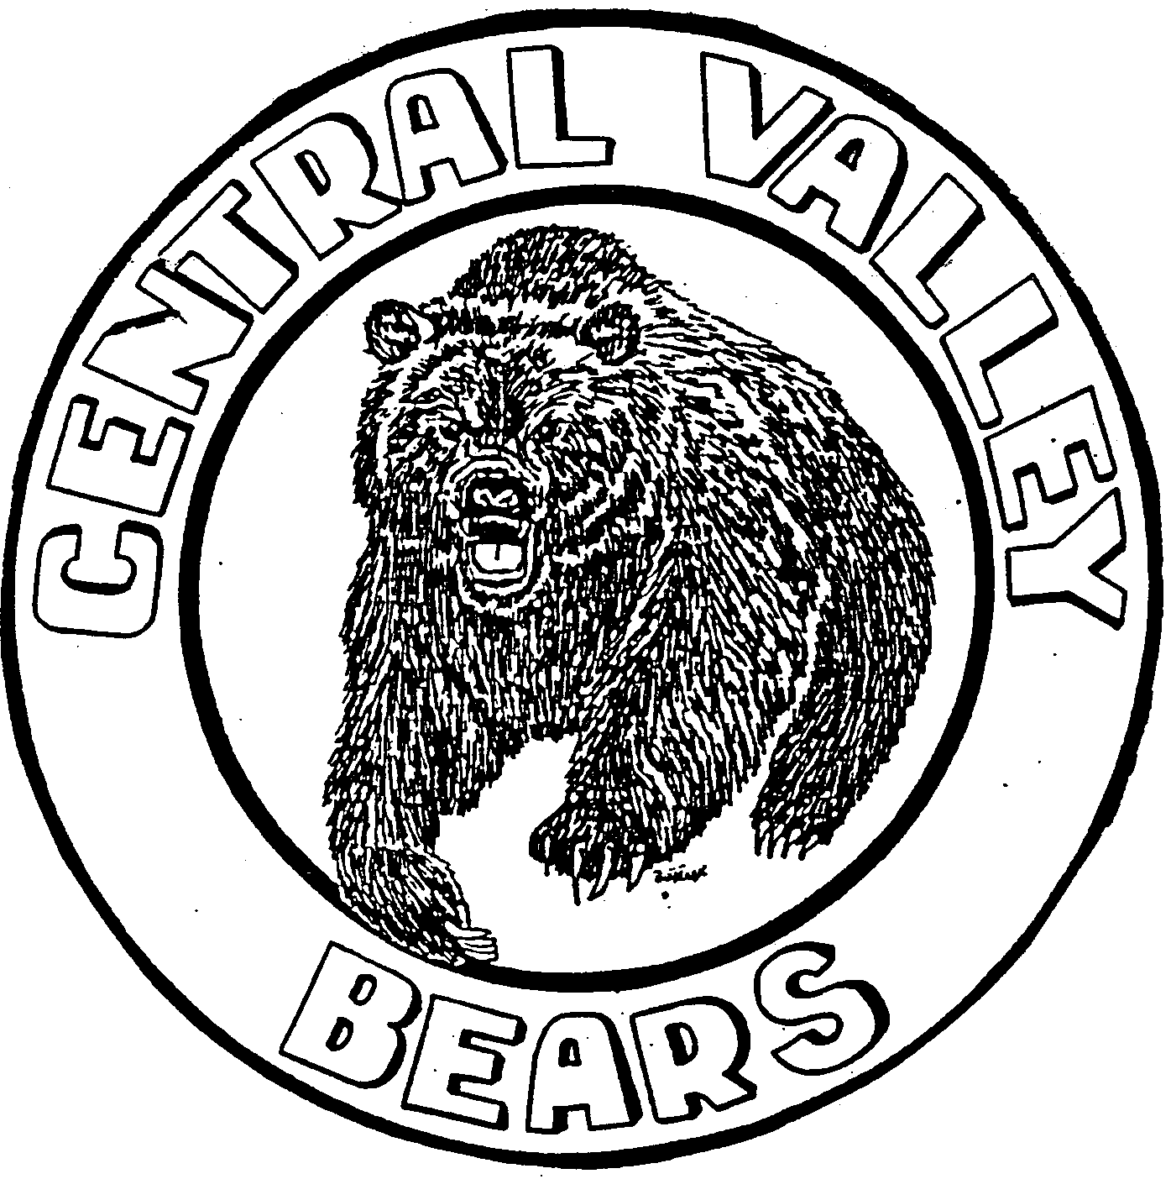
Attn: Wrestling Coach/Athletic Director:
2019 CVHS GIRLS CLASSIC
PLEASE
CONFIRM ASAP

Activities and Athletics
South 821 Sullivan Road Veradale, Washington 99037
Office: (509) 558-5100
Fax (509) 558-5109

CALL
Please call or e-mail BUTCH WALTER at (509-869-2023) ggwalter@msn.com to confirm your school’s participation in the 2019 Girls Classic Wrestling Tournament at Central Valley High School.

DATE & TIME: Saturday, December 7, 2019 - 9:30 am to approximately 5:00 pm

WEIGH IN: 7:30 am by Team

ENTRY FEE: Registration Fee $250 ($200 for 7 or fewer wrestlers) if paid by Dec. 7, 2019
NOTE: (Each wrestler over 14 will be an extra $20)
Late Registration Fee $300 ($250 for 7 or fewer wrestlers) if paid after Dec. 31, 2019

FORMAT: Girls: We will run WIAA Female Weights. Brackets will be based upon number of entrants in each weight class. Weight classes will be combined as needed.

AWARDS: Trophy for 1st Place Team and Medals to TOP THREE (3) placers in each weight class.

SEEDING: Returning state/regional participants.

TRACK WRESTLING REGISTRATION: Information will be sent to teams that have confirmed by December 2.
Please update wrestler information on Track Wrestling through Friday, December 6.

TEAMS:
*Central Valley
Columbia-Burbank
Davis
Deer Park
East Valley
Ephrata
Ferris
Grandview
Granger
Hanford
Kennewick
*Liberty

*Mary Walker
*Mead
Moses Lake
Newport
Othello
Pasco

*Shadle Park
Sunnyside
Union
Warden
West Valley
Zillah
*Teams that have confirmed
Kerri Ames  Principal | Robin Barnhart  Assistant Principal  Activities & Facilities | Shaun Williams  Head Coach | Butch Walter  Tournament Director  ggwalter@msn.com
cc: Suzy Orth, Shaun Williams, Lori Wilson

