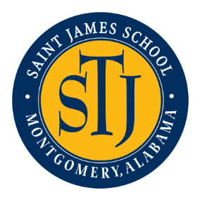
2020 Julian McPhillips Tournament
January 3-4, 2020
Saint James School, Montgomery AL
http://stjweb.org/about/tour-the-campus/directions/

- Seeding will be done online through Trackwrestling based on information entered by Coaches. Directly following weigh-ins, we will have a coaches’ meeting.

- Three mats will be used and it will be a double elimination tournament.

- Weigh-ins will be from 4-5:00pm on Friday night and 7- 8:00am on Saturday morning. Wrestling will begin at 6:00pm Friday night and 8:30am on Saturday.

- Entry fee will be $200 per team. Please make checks out to Saint James School.

- Team trophies will be presented for 1st-4th places and individual medals will be awarded to wrestlers for 1st-4th places in each weight class.

- A Hospitality Room will be provided for Coaches.

- One team cooler allowed. A concession stand will be open for fans.

Coach Jeff Corley
jcorley@stjweb.org
334 546-3093

