2020 Gator Brawl

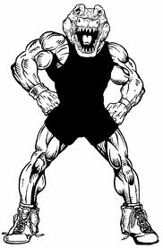
DATE:
January 17th & 18th
Location:
Wewahitchka High School 1 Gator Circle
Wewahitchka, FL 32465
Format:
Scramble format on 4 mats
(4th mat after school lets out Friday) We average 8 matches per wrestler.
Weigh-ins & Coaches Meeting: 10 AM Friday 9 AM Saturday
Wrestling Begins: Noon Friday 10 AM Saturday
Tournament Fee: $300 per team
Gate: $6/day or $10/weekend
Awards for top 3 wrestlers in each class. First and Second place team awards. Outstanding Wrestler in Lower and Upper Weight Classes.
Northwest Floridas BEST Hospitality room for coaches and officials. Full concessions.
For info, contact Coach Tracy Malcolm 850-532-4886. Email wewawrestling@gmail.com
2020 Teams: Arnold, Bay, Bozeman, Chiles, Crestview, Columbia, First Baptist Christian Academy, Gulf Breeze, Marianna, Mosley, North Bay Haven, Pace, Raines, Ridgeview, Rocky Bayou, Rutherford, South Walton, Tate, Wakulla, Wewahitchka.

