W.S. Neal Eagles Wrestling
2019 Gulf Coast Clash
When: Friday November 22nd and Saturday November 23rd

Where: Mobile Civic Center
401 Civic Center Dr.
Mobile, AL 36602

Time: Weigh In 12:00 noon – 1:30 pm ; Wrestling begins at 2:00 pm (Friday)
7:00 am – 8:00 am ; Wrestling begins at 8:30 am (Saturday)

Cost : $350 per team if received before 10/31; $450 per team if received on or after 11/1.
Please send checks to
W.S. Neal High School
ATTN: Coach J.T. Gosnell
801 Andrew Jackson St.
East Brewton, AL 36426

Admission: Adults $15.00 on Friday or Saturday (Single Day);
Adult 2-Day Passes: $25.
Parking: If you choose to park at the venue, the Mobile Civic Center charges a $5 parking fee. W.S. Neal Wrestling does not have any control over this fee. Team busses will be allowed to park for free.

Format: 32-man scramble bracket or 40-man scramble bracket. Trophies for the Top 3 teams. Medals for the Top 8 wrestlers in the Championship bracket of each weight class only.
- 40-man scramble bracket
  - Each wrestler is pooled in a 5-man pool (A-H). After pool play, wrestlers are placed in one of two 16-man brackets per weight class, based on pool results. However, the wrestler who finishes 5th in each pool will be eliminated from the tournament.
- 32-man scramble bracket
  - Each wrestler is pooled in a 4-man pool (A-H). After pool play, wrestlers are placed in one of two 16-man brackets per weight class, based on pool results.

Hotel: The Admiral Hotel Mobile, Curio Collection by Hilton
251 Government Street
Mobile, AL 36602
(251) 432 – 8000
$119 per night Single and Double Rooms
To make reservations, please call 1-800-774-1500 and use the Group Code: GCCW or visit them online at www.theadmiralhotel.com and enter special code GCCW.
Competition: This year’s tournament features 5 defending state championship teams as well as 21 returning inidividual state champions, 18 returning state finalists, 47 returning state placers, and 96 returning state qualifiers from Alabama, Louisiana, and Georgia.
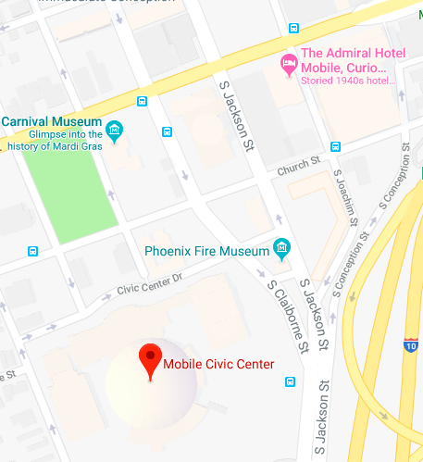
Downtown Mobile: The Admiral Hotel (official tournament hotel) is both walking distance from the venue and the Mobile entertainment district.

