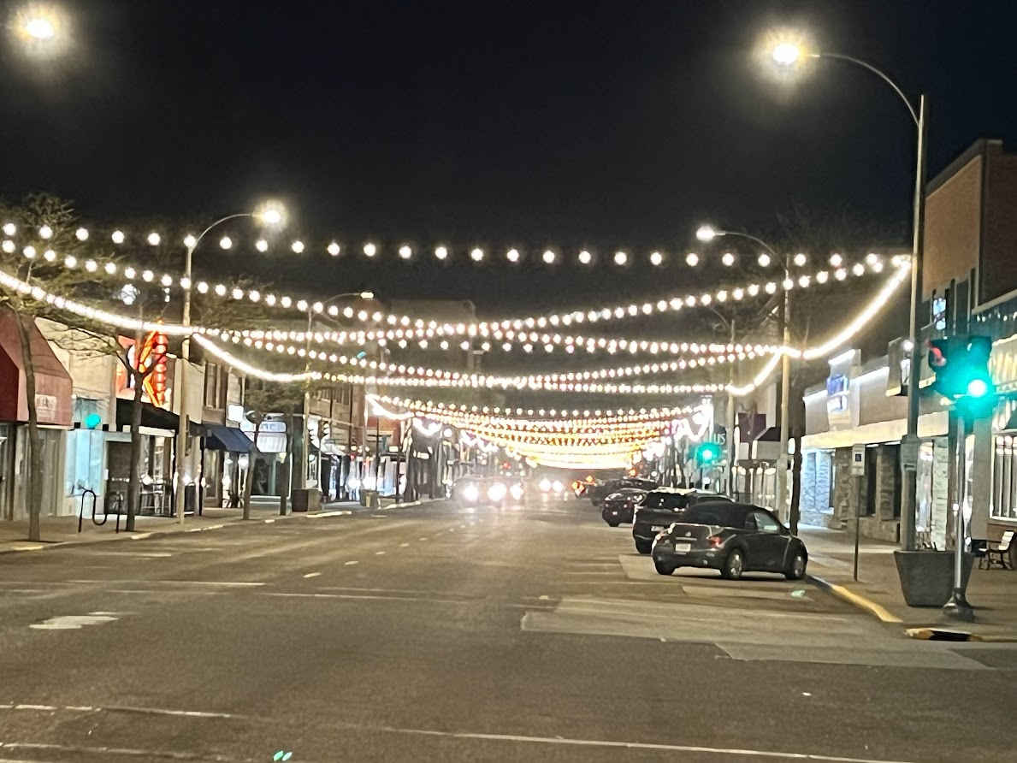
Friday Night Lights Tournament
Railside
200 Block of W 3rd St
Grand Island, Nebraska, 68803
Friday June 28, 2024 Pre-Register only. No walk-ins.
Deadline for registration is Wed June 26, 2024 11:00 pm
Register on Trackwrestling
Registration Link
Limited to the first 250 wrestlers!!
Cost $25.
Questions: Contact: Jeff Paige 308-380-2001 jeffreyraypaige@gmail.com
Brian Sybrandts 308-379-7054 bsybrandts@ginorthwest.org

USA wrestling card required
All brackets will be 4 person place 4. Awarding first place medals only! We will start wrestling at 6:00 pm sharp. Once started we will not stop. All matches start in a neutral position. All matches are three 1:30 periods running clock.
Six Divisions based on grade entering 24-25 school year.
Grades 3-5 Girls Grades 3-5 Boys
Grades 6-8 Girls Grades 6-8 Boys
Grades 9-12 Girls Grades 9-12 Boys

Weigh-ins will start at 3:30 pm and will close at 5:00 pm. Must weigh in wearing a singlet. If a wrestler's weight is 3 lbs more than weight on track, they will be disqualified and no refund will be given. No refund on a no show. Rate your wrestler as a beginner, average, good, or excellent.There will be no crossover between Girls and Boys Division. A wrestler may be moved to a higher grade division if necessary and parent/coach approved.

