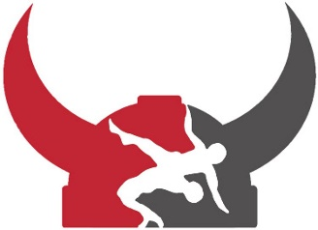

### MOUNT HOREB AREA WRESTLING

Saturday, April 20th, 2024

## Freestyle & Greco Wrestling Tournament

***Registration***

Only preregistration on trackwrestling.com

***Schedule***

Saturday, April 20th, 2024

7:30 AM – Doors Open with checkins with weigh ins until 9:00 a.m.

9:30 AM – Freestyle Wrestling all age groups

1:00 PM or 30 minutes after the completion of Freestyle- Greco Wrestling Begins for Boys and Girls Kids Ages

Age Groups:

|  |
| --- |
| 8U (2015-2016) |
| 10U (2013-2014) |
| 12U (2011-2012) |
| 14U (2009-2010) |
| 16U (2007-2008) |
| Junior Born 9/1/04* |
|  |
| |  | | --- | | Girls 8U (2015-2016) | | Girls 10U (2013-2014) | |  | | Girls 12U (2011-2012) | | Girls 14U (2009-2010) | | Girls 16U (2007-2008) | | Girls Junior Born 9/1/04* | |
|  |
| * or after but still enrolled in 9-12 grade for spring of 2024 semester |
|  |
|  |
|  |

Contact: Kayla Spurley at 608-574-6823 or sandrwrestling@gmail.com

**Additional** -Concessions will be available all day

**Information:** - Double-bracketing is allowed

- Custom medalsfor placements

- ***Choice of custom 1st Place T-Shirts or medal*** for 14U and 16

$25 for one style & $35 for both styles

Red & Blue Singlets are required for all Ages!

Held at the Mount Horeb High School at 305 South 8th Street