KS Heartland Duals Qualifier & 6U State

KANSAS STAR ARENA, Mulvane, KS

MARCH 3rd, 2024
KANSAS 6 UNDER
STATE CHAMPIONSHIPS
COME TAKE HOME THE BELT!!!!!
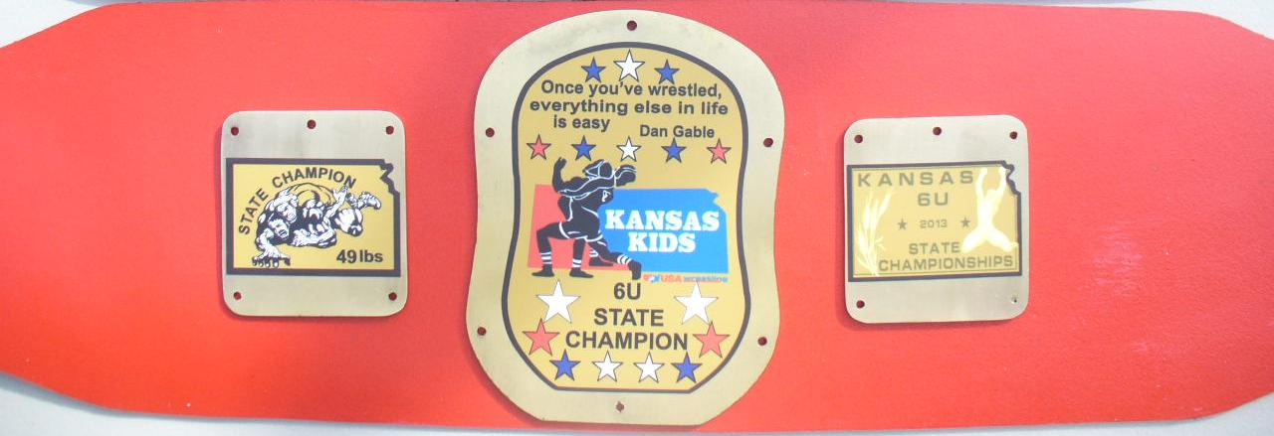
Awards
Champions – Belt, 2nd – 6th Medals
Weight classes
37, 39, 41, 43, 45, 47, 49, 51, 53, 55, 58, 61, 64, 67, 70, 73, 80, 88, 95 & HWT

6 UNDER GIRLS
Block weights

Qualifying tournament for TEAM KANSAS Elementary, Middle School, and Girls Dual Teams going to Council Bluffs, IA on March 28-30, 2024.

Elementary State Championships
1st-6th grade
Weight Classes: 50, 55, 60, 65, 70, 75, 80, 85, 90, 95,100, 105, 112, 120, 130, 140 and 160
NO WEIGHT ALLOWANCE WILL BE GIVEN
We will take 6 teams

Middle School Championships
6th-8th grade
Weight Classes: 75, 80, 85, 90, 95 102, 110, 117, 125, 132, 140, 150, 160, 175, 195, 220 and 275
NO WEIGHT ALLOWANCE WILL BE GIVEN
We will take 6 teams

Girls Championships
Weight Classes: 52, 58, 65, 73, 82, 89, 95, 101, 107, 113 120, 126, 138, 150, 165, 185

NO WEIGHT ALLOWANCE WILL BE GIVEN
We will take 3 teams
Enter Fee: $25.00
Enter on TrackWrestling.com.
Enter Deadline is February 28th @ 11:59pm
This will be a spilt tournament.
SUBJECT TO CHANGE
All depends on number of entries.
AM Starting 8:30
Middle School Boys / Girls/ 6 U Girls

PM Starting no earlier than 11:30
Elementary / 6 and Under Boys

Weigh in will be held Friday night at the district weight ins.
The Friday night weigh in will count for the weigh in for Sunday.
Contacts:
Middle School/ 6U
James Cook-785-212-0605 cookjt@cox.net
Elementary
Dal Eck- 316-641-4913 dal@matteck.com
Girls
Travis Phippen 913-669-4016 Tkphippen@gmail.com

All Wrestlers must have a USA Wrestling Membership Card
Coaches must have Bronze Card. KSHSAA rules w/ kids’ modifications.
Cost of Admission. $8.00

