Stevens Point High School Commuter Camp
Featuring 2x NCAA Finalist Sammy Sasso
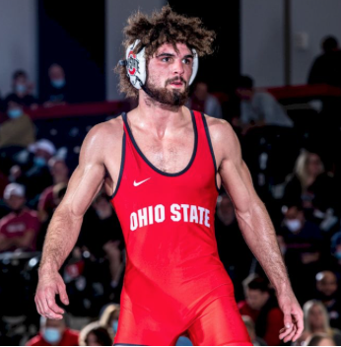

5 Nights - Monday June 12, Through Friday June 16, 5:00 p.m. – 7:00 p.m.
Sammy Sasso Is The Featured Technician Monday/Tuesday/Wednesday
Freestyle & Greco groups available for those going to Northern Plains & Fargo
Additional Technicians:

Brady Koontz Fritz Schierl Dylan Koontz
4x US National Team Member US World Team US National Runner-Up
3x US World Team Trials Finalist Trials Runner-Up US Open 3rd Place
2022 Pan Am Games Champion
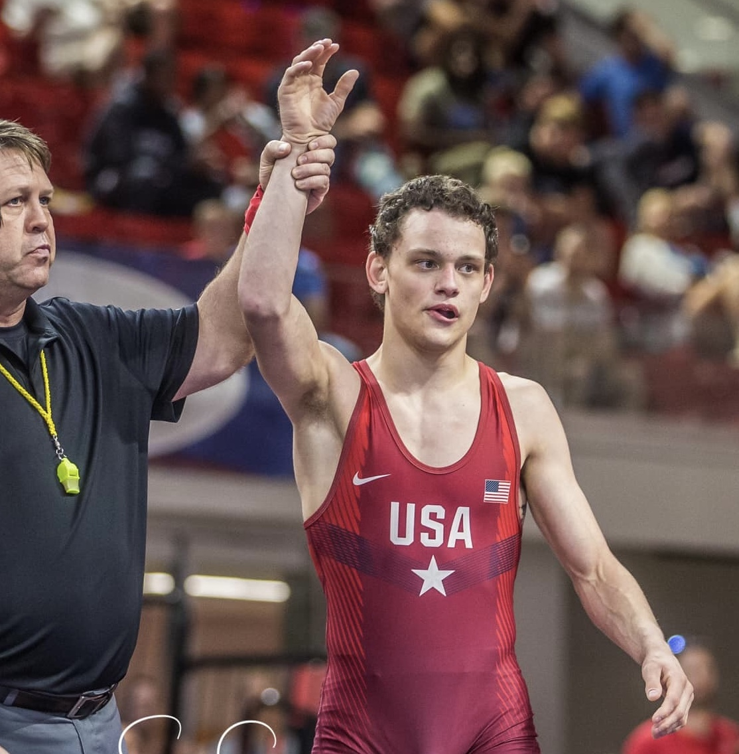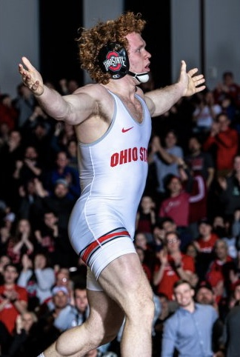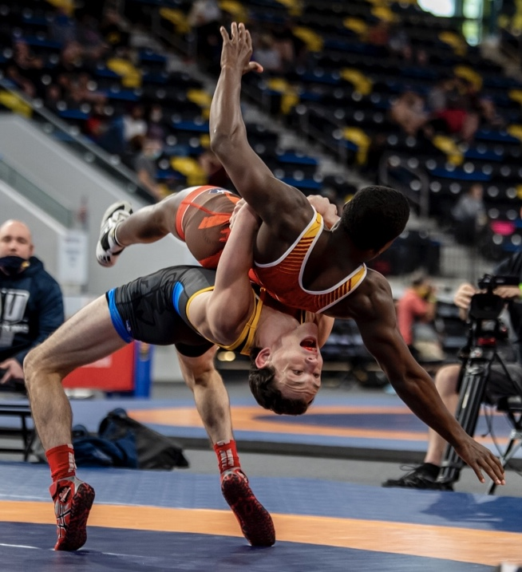

Reserve Your Spot at www.trackwrestling.com
Payment of $125 with cash or check will be accepted prior to the first practice session, but those pre-registered through trackwrestling will receive a $5 discount on their individual cost. USA Wrestling Card Required. Make all checks payable to: SPASH Wrestling Booster Club.
Contact: Bryan Koontz 715-498-4910

