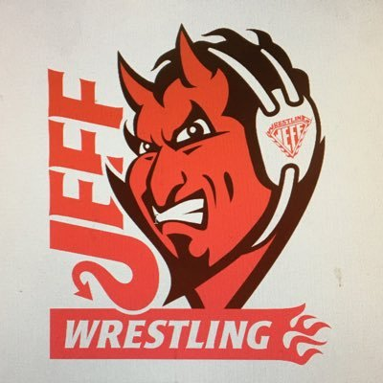
Freestyle- Friday 6pm to ?, Greco-Saturday 9am, Folkstyle- begins 45 minutes after Greco
Girls Freestyle- Saturday 9am (same as Greco)
LIMITED TO THE FIRST 300 WRESTLERS (SIGN-UP EARLY!)

LINKS TO REGISTER: http://www.trackwrestling.com/registration/TW_Register.jsp?tournamentGroupId=228202132

LOCATION
Jeffersonville High School, 2315 Allison Lane, Jeffersonville IN 47130– enter door 15

CONTACT: Joe Somerville jsomerville@gccschools.com 502-821-4199 or Danny Struck 812-786-2308 dstruck@gccschools.com

SANCTION – ELIGIBILITY
Tournament is sanctioned through the Indiana State Wrestling Association by USA Wrestling and is open to all current USA Wrestling members

ENTRY FEE
$20.00 for one style $30 for both, $40 for all three (paid on www.trackwrestling.com only)
NO additional fee for weight change

AGE DIVISIONS 6U (PEE-WEE) – 18U (Junior)

REGISTRATION & WEIGH-INS
Jeffersonville is on Eastern Time – Same as Indianapolis & Louisville; One hour ahead of Evansville
All times listed are EST times
All wrestlers must be registered on www.trackwrestling.com by 8:00pm Thursday, 4/6/2022
No On-Site Registrations. Out of state wrestlers are welcome.
USAW cards must be purchased at usawrestling.com. Cards not required to be shown onsite.

Weigh-ins and Skin Checks:
ONSITE: Friday 5pm and Saturday - 7:30-8:30 am
SATELLITE: Weigh-ins encouraged, but must be approved- Contact Coach Struck - must be a club weigh in, not an individual - Spreadsheet with Names, age group, USAW#, Weight class, and actual weight, club name - Wrestlers must be wearing a competition singlet for weigh-ins and skin checks
Check-in times: 6pm Friday, and 8:30am Saturday
Wrestlers who have not checked in PRIOR TO 8:30 am will be scratched from the tournament
Wrestling starts at 9:30am (be prepared to start early)
AWARDS Medals for 1st 2nd 3rd places;
ADDITIONAL INFORMATION
Spectator Fee: $5.00 per person day; $15 per family per day

