Diesel City Folkstyle Nationals

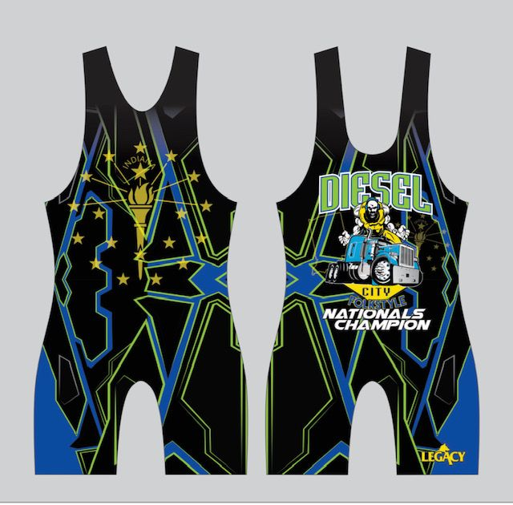 | Men’s & Women’s Divisions  February 26, 2023  Columbus North High School  1400 25th Street Columbus, IN 47201 (Door 36 or 40)  Tournament Director:  Justin Ratliff (812) 525-7304  cndogswrestling@gmail.com

SANCTION - ELIGIBILITY
Tournament is sanctioned through the Indiana State Wrestling Association by USA Wrestling and
is open to all participants with a valid 2022-2023 USA Wrestling athlete card

ENTRY FEE
$30 (online registration through trackwrestling.com)

AGE DIVISIONS
ISWA Men’s Weights: 6U through Junior
Women’s Divisions (Madison Block Weights): 6U – Junior

REGISTRATION & WEIGH-INS
Register at www.trackwrestling.com Registration closes at 10 pm EST on Saturday, Feb. 25th
Weigh in singlet (NO weight allowance) Onsite weigh-ins only. MUST weigh-in to wrestle!
EARLY WEIGH-IN: Saturday, February 25th 6-8 pm (Door 40)

SESSION 1:
Boys 6u, 8u, 10u, 16u, & all Women’s divisions
DOORS OPEN: 7 am WEIGH-IN: 7:30-8:15am WRESTLE: 9:00 am

SESSION 2:
Boys 12u, 14u, & Junior
WEIGH-IN: 10:30-11:30am WRESTLE: 12:30 pm

AWARDS
1st place in each weight class earns custom Diesel City Champion singlet. Medals for 2nd-6th
Team Competition: Banners for top 3 teams, top academy, and top Women’s team

SPECTATOR FEES
$5 per person, $10 per family (5 and under free)
Coaches admitted free with current USAW coach’s card.

*Pairing official will combine weights where appropriate to facilitate matches. Out of state wrestlers welcome. Equipment and Apparel for purchase. Concessions by Junkyard BBQ & Ice Cream
USAW cards required! Purchase at www.usawmembership.com

