Pittsburg Wrestling Club
Presents the
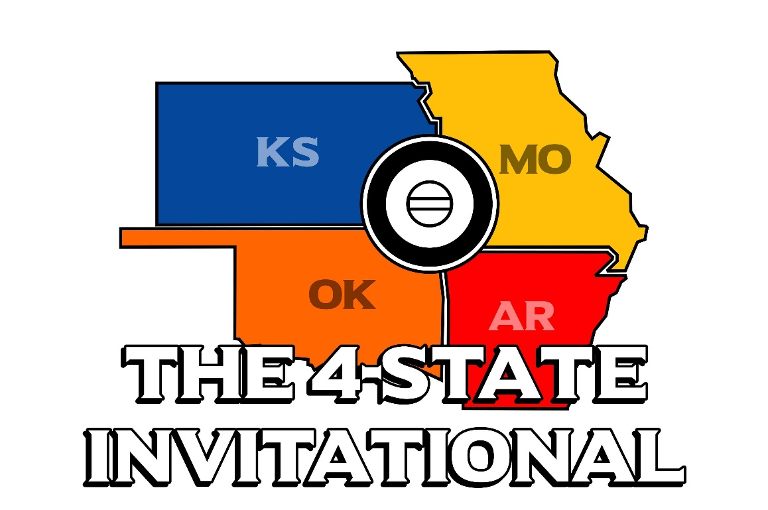

Date: Sunday, February 5th 2023
Location: Pittsburg High School, 1978 E. 4th Pittsburg, Kansas (The Main Gym and the MMAC gym will both be utilized)
Admission: Adults $5, Kids (K-12) $3
Time:
- Doors Open at 7:30am
- Coaches Meeting at 8am
- Session #1 – (ALL 8U & 12U) begins at 8:30am
- Coaches Meeting 12:30pm
- Session #2 – (ALL 6U, 10U & 14U) begins approximately 1:00pm
Concessions: Breakfast and Lunch will be available. A hospitality room will be available for Coaches and Referees. No outside food or drinks will be permitted.

Registration and Fees:
- $100 per team that is invited (5 wrestlers’ entry and 2 coach band/meal tickets) This fee needs to be paid ASAP with estimated amount of wrestlers your club plans to attend. You will not receive the link to enter roster until this is paid
- $20 per additional wrestler (Checks payable to PWC at weigh-ins or check-ins)
- Send Payment: Pittsburg Wrestling Club (PWC), 504 Norris Drive, Pittsburg, KS, 66762. Please send check along with the following: Club/Team Name, Two Coaches (bands), Phone Number & Email Address
Divisions: Open, Girls & Novice
Format:
- Session #1: (ALL 8U & 12U)
- Session #2: (ALL 6U, 10U & 14U)
- Double elimination brackets used when possible
- Round Robin brackets may be used if necessary.
- Weight classes are subject to consolidation to pair wrestlers of similar size and experience levels.
- Each club can enter 10 point scoring wrestlers per age division (Open/Girls)
Weigh-Ins: Saturday Night at Hampton Inn and Suites – Pittsburg from 4-6:00pm (connected to the Kansas Crossing Casino)
Must weigh in a singlet. NO weight allowance. (A few assigned remote locations will be available)
Awards:
- Team Awards for Top Three Teams will earn a 4-State Invitational Banner
  - Combined Team score from Open & Girls division (no team score for novice)
- Top Three will receive medals in all three divisions
KSHSAA rules as modified by USAWKS, Kansas Kids rules apply.
Divisions & Weight Classes: (We reserve the right to combine brackets)
- 6 & Under: 37, 40, 43, 46, 49, 52, 55, 58, 61, 64, 67, 70, 73, 76, 80, 88, 95, HWT
- 8 & Under: 40, 43, 46, 49, 52, 55, 58, 61, 64, 67, 70, 73, 76, 80, 88, 95, 110, 125, HWT
- 10 & Under: 52, 55, 58, 61, 64, 67, 70, 73, 76, 79, 82, 85, 90, 95, 100, 110, 120, 130, 150, 170, HWT
- 12 & Under: 64, 68, 72, 76, 80, 84, 88, 92, 96, 100, 105, 110, 115, 120, 130, 140, 150, 165, 190, 215, 240, 265
- 14 & Under: 80, 85, 90, 95, 100, 105, 110, 115, 120, 125, 130, 135, 140, 145, 150, 155, 165, 175, HWT
- Girls: Madison Bracketing

Tournament Director: Pittsburg Wrestling Club, LC Davis (660)229-3384, lc.davis@ymail.com or lcdavis@usd250.org
Bracketing Official: Chris Ball cball@usd504.org
Pittsburg Wrestling Club and/or USD 250 will not be held responsible for accidents or lost/stolen property that may occur on the premises or in the parking lot, whether directly or indirectly.

