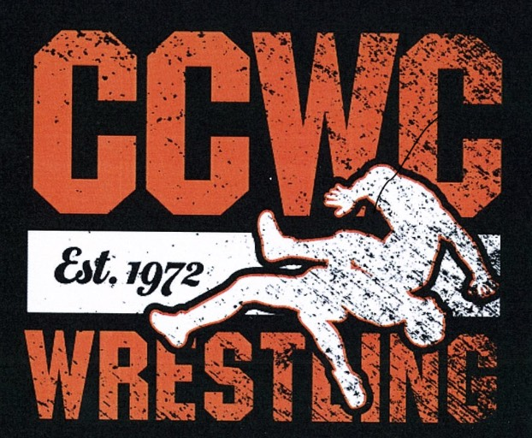
2023 Greg Grater Classic
Clay County Wrestling Club

Date: February 4, 2023

WHERE: Clay Center Community High School, 1630 9th Street, Clay Center, KS

ENTRY FEE: $25.00 per participant (non-refundable). Each participant must have a current USA Wrestling card. Registrations are to be handled thru Track Wrestling at www.trackwrestling.com

ENTRY DEADLINE: Entries and any changes are due by Wednesday, February 1st by midnight. No changes allowed after that date. Tournament will be limited to first 400 entries.

WEIGH-IN: We will be allowing home site weigh-ins on Friday evening February 3rd at no earlier than 5:00 pm and must be entered into track by 7:00 pm. No Weight Allowance, No Changes after date posted, and No Saturday Weigh-In. All scratches at mat side.

All wrestlers must make weight and weigh in wearing a competition singlet. We do not allow double dipping. However, tournament directors reserve the right to move a wrestler or combine weights.

COACHES MEETING: 8:15 am

WRESTLING STARTS: 9:00 am

AWARDS: Trophies for 1st Place and a Custom Medal for 2nd thru 4th place finishers in each bracket.

RULES: High School Rules with Kansas Kids Modifications. Coaches and wrestlers ONLY at mat side. All coolers, food, and drinks must remain in the Commons Area. NO SMOKING OR CHEWING OF TOBACCO PRODUCTS IS ALLOWED ON USD #379 SCHOOL GROUNDS.

WEIGHTS: Age divisions will be age as of August 31. We reserve the right to combine weight classes / brackets, as we deem necessary.

Boys Division:
6 & Under: 37, 40, 43, 46, 49, 52, 55, 58, 61, 64, 67, 70, 73, 76, 80, 88, 95, 110
8 & Under: 40, 43, 46, 49, 52, 55, 58, 61, 64, 67, 70, 73, 76, 80, 88, 95, 110, 125, 140
10 & Under: 52, 55, 58, 61, 64, 67, 70, 73, 76, 79, 82, 85, 90, 95, 100, 110, 120, 130, 150, 170, 190
12 & Under: 64, 68, 72, 76, 80, 84, 88, 92, 96, 100, 105, 110, 115, 120, 130, 140, 150, 165, 190, 215, 240, 260
14 & Under: 75, 80, 85, 90, 95, 100, 105, 110, 115, 120, 125, 130, 135, 140, 145, 150, 155, 160, 165, 175, 205, 235, 265

Girls Division
6 & Under: 37, 40, 43, 46, 49, 52, 55, 58, 61, 64, 67, 70, 76, 80, Hwt
8 & Under: 40, 45, 50, 55, 60, 65, 70, 80, 90, 110, 125
10&Under: 50, 55, 60, 65, 70, 75, 80, 85, 90, 100, 110, 125, 140
12 & Under: 65, 70, 75, 80, 85, 90, 95, 100, 105, 110, 115, 120, 130, 140, 150, 165, 185
14 & Under: 72, 79, 85, 92, 97, 101, 105, 110, 115, 119, 127, 136, 145, 165, 185, 200

RATINGS: (A) State Qualifier/Placer (B) Above Average (C) Average (D) Beginner/Novice

CONCESSIONS: Concessions will be available throughout the entire day, starting with breakfast. All coolers, food, and drinks must remain in the Commons Area.

ANY QUESTIONS CAN BE DIRECTED TO:

Email: ccwcwrestling@gmail.com
Phone: Michelle Alquist 785-632-1228
Eric Alquist 785-632-7069

Members and parents of the Clay County Wrestling Club, Clay Center Community High School employees, administrations, or USD #379 are not responsible for any injuries, theft, or vandalism during the tournament.

