The Spartan Rumble

Date: January 29, 2023

Location: David S. Palmer Arena – 100 W. Main St., Danville, IL 61832

Entry Fee: $35 Per Wrestler (**NO REFUNDS**) **Must be listed on team roster or have current USA Wrestling Card**

Registration: Pre-registration only through trackwrestling.com from 12/12/22 – 1/25/23. **No walk in’s**
Limited to first 800 wrestlers registered (400 wrestlers per session)

Split Sessions:
Session 1 – 8:30 am start for Tots & Bantam
Session 2 - 12:00 pm start for Intermediate, Novice & Senior

*THERE WILL NOT BE STAGING – BOUTS WILL BE ASSIGNED TO MATS ON TRACKWRESTLING*

Weigh-In’s: at David S. Palmer Arena
Saturday 1/28/23 5:30pm-7:00pm (ALL DIVISIONS)
Sunday 1/29/23 6:00am-7:30am (ALL DIVISIONS)
9:30am-11:00am (Intermediate/Novice/Senior)

Age Divisions: IKWF Divisions – age by 12/31/22
Tot 6 & Under / Bantam 7&8 / Intermediate 9&10 / Novice 11&12 / Senior 13&14

Brackets:
4-man Round Robin for Tots and Bantam. 8-man bracketing when possible for Intermediate, Novice and Senior Divisions.

Awards: Individual trophies to 1st/2nd/3rd, medals to 4th/5th/6th.
Team trophies to 1st/2nd/3rd – Trackwrestling scores top 10 wrestlers on team roster

Concessions: Arena food/drinks available all day for wrestlers & spectators. Hospitality room for coaches and officials.
*NO OUTSIDE FOOD/DRINKS ALLOWED PER ARENA*

Admission:
Adults - $5.00 Students - $3.00 Children 5 & Under - Free

Coaches:
Must have current USA Wrestling Coaches Card and photo ID (this includes out of state coaches).
Only coaches with wrist band and coaches card displayed will be allowed on the wrestling floor. Two coaches per mat.

**For further information or questions**
Send an email to sjospartanywc@gmail.com or contact Billy Gallo 217-493-9071

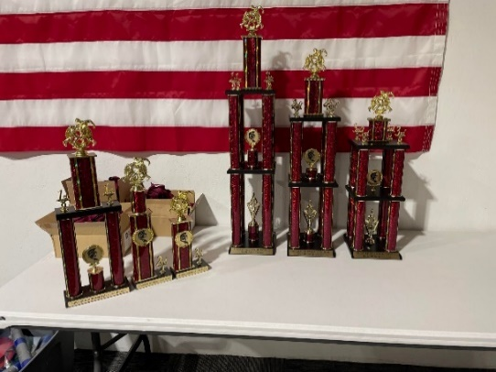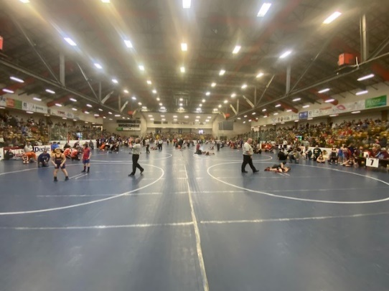
-THANK YOU-
TO OUR SPONSOR

