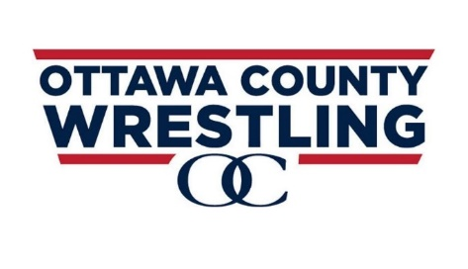

Ottawa County Open/Novice/Girls
Saturday January 28th, 2023

Minneapolis High School (New Gym)
602 Woodland Ave, Minneapolis, KS

Entry Deadline: Thursday, January 26th at 9 pm- Track Wrestling
Entry Fee: $25.00 Non-Refundable

Rules: This is a sanctioned tournament with USA Wrestling & USA Wrestling-Kansas, KSHSAA rules as modified by the USA Wrestling-Kansas Kids Rules. Headgear required.
USAW member card required for all wrestlers
USAW coaches card required for all coaches
Coaches meeting at 8:30 am, Wrestling starts at 9 am

Questions?: Jessica Johnson Ph. 785-407-0365 or email OCWCKS@gmail.com

***Concession stand will be available
Home Site Weigh-in: Friday night weigh-in by 7:30 pm—Email weights to ocwcks@gmail.com-- No SATURDAY weigh-ins—NO bracket changes after coaches meeting- We reserve the right to combine weight classes***
Weights:
6 & U: 37 40 43 46 49 52 55 58 61 64 67 70 73 76 80 95 HWT
8 & U: 40 43 46 49 52 55 58 61 64 67 70 73 76 80 88 95 110 125 140
10 & U: 52 55 58 61 64 67 70 73 76 79 82 85 90 95 100 110 120 130 150 170 190
12 & U: 64 68 72 76 80 84 88 92 96 100 105 110 115 120 130 140 150 165 190 215 240 265
Girls—Pooled weight classes (K-2nd Grade, 3rd- 5th Grade, 6th to 8th Grade)
Awards: Top 4 will receive medals

