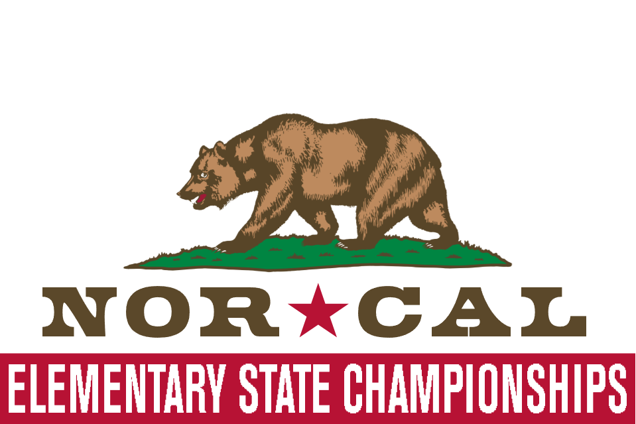

WEIGH-IN SCHEDULE

**Friday**

All kids can weigh in between 5:30PM-7:00PM

**Saturday**

K-1st weigh in from 5:30-7:00 AM

(All wrestlers can weigh in at this time, too)

2nd-3rd weigh in from 8:00-8:30 AM

4th-5th weigh in from 10:00 AM-10:30AM

6th-8th weigh in from 1:30PM-2:00PM

**WRESTLING SCHEDULE**

8:00 K-1st Grade wrestling until finished

10:00 2nd-3rd Grade wrestling until finished

12:30 4th-5th Grade wrestling until finished

3:00 6th-8th Grade wrestling until finished

(PLEASE NOTE THE STAGGERED START TIMES)

**REGISTRATION COST**

$30 for preregistered (must be preregistered by 2/9/2023)

$45 for non-preregistered (payable at weigh-ins)

**ADMISSION PRICE**

$5 for Adults (Children 12 and Under are FREE)

**AWARDS**

Trophies for Champion medals for 2nd-3rd

**FORMAT**

Line bracketed tournament

**CONTACT**

Jennifer Griffith 530-828-4218 for questions

**Saturday, February 11, 2023**

**Glenn County Fairgrounds, 221 East Yolo Street, Orland, CA 95963**

Orland Wrestling Club invites you to join us for the 7th Annual ‘NorCal Elementary State Championships’ in Orland, California. This is always THE LARGEST kindergarten through fifth grade tournament in Northern California, and it’s going to be even bigger this year. we have added 6th thru 8th grade. We have staggered start times to get you in and out …you don’t want to miss it.

**DIVISIONS & WEIGHT CLASSES**

K-1st Grade: 35, 40, 45, 50, 55, 60, 65, 70, 75, HWT (90 Max)

2nd-3rd Grade: 40, 45, 50, 55, 60, 65, 70, 75, 80, 85, 90, HWT (105 Max)

4th-5th Grade: 60, 65, 70, 75, 80, 85, 90, 95, 100, 105, 110, 115, 120, 125, 130,135, 140, 145, 150, 160, HWT (170 Max)

6th-8th Grade: 70, 76, 83, 89, 95, 100, 103, 108, 112, 116, 122, 128, 135, 142, 153, 168, 185, 205, 235, HWT (245 MAX)

**REGISTRATION:** Register on Trackwrestling

[**http://www.trackwrestling.com/registration/TW_Register.jsp?tournamentGroupId=210127132**](http://www.trackwrestling.com/registration/TW_Register.jsp?tournamentGroupId=210127132)