When: Sunday – December 11th, 2022
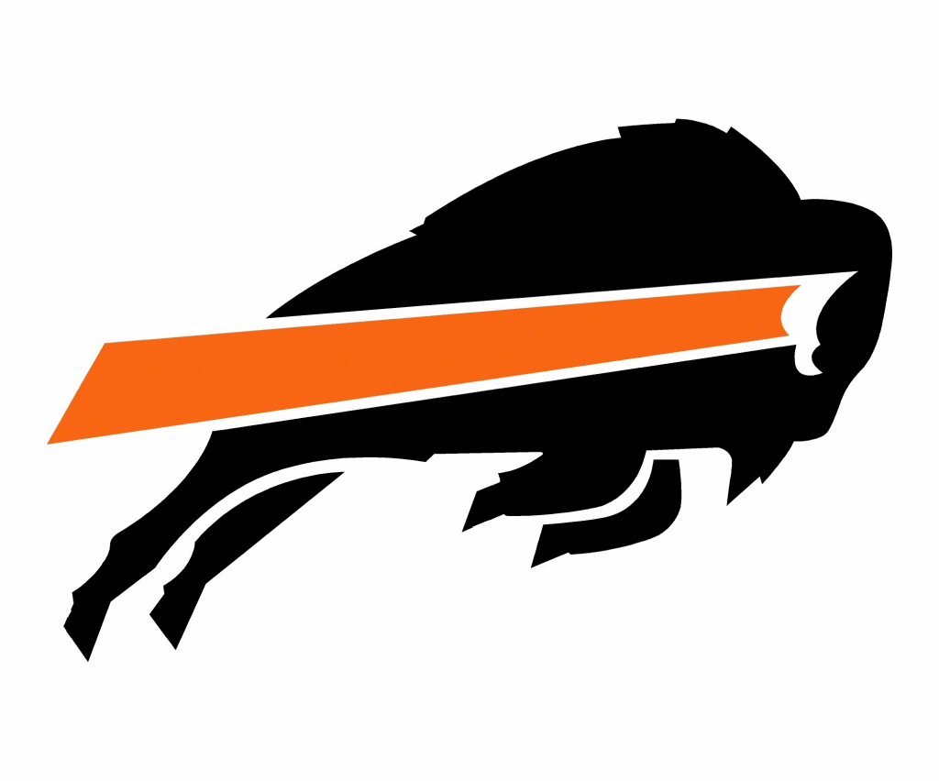 Onaga Winter Rumble
Where: Onaga High School 500 High Street, Onaga, KS 66521
Entry Fee: $20 NON-REFUNDABLE
Limit: Limited to first 400 paid entries. Limits will be strictly followed. Get your entries in early!! We will be using 2 side-by-side gyms, 4 full mats split in halves so 8 Running mats.
Enter Wrestlers: www.trackwrestling.com All entries must be entered at http://www.trackwrestling.com/registration/TW_Register.jsp?tournamentGroupId=210090132 (NO ONSITE REGISTRATION) registration will close once entry cap has been reached or 12-7-2022 at 11:59 PM
Email questions to: niehueschris08@gmail.com
Contact Info: Chris Niehues 785-456-5408 Brandon Spevacek spevacek@fumainsurance.com
Head Official: Tim Horgan ^^^785-268-1010^^^
Weigh In: Saturday, December 10th, 2022 by 12:00 PM. Home Site Satellite weigh in is allowed.
*Girls division will be grouped by age and as close to weight as possible. If this is not a possibility, they will be re-grouped into the Open division to ensure adequate opportunity to compete. Clubs are responsible for weigh-ins. Bronze Certified Coaches are responsible for skin & nail check, and must input weights on trackwrestling.com by 12:00 PM Saturday 12/10/2022. Instructions (username & password) for inputting weights will be emailed prior to weigh in. Send club emails to niehueschris08@gmail.com If weight is not received, we assume the wrestler is a scratch or you have contacted Chris Niehues in advance.
Coaches Meeting: 8:00am (brackets posted at 8:30am)
Wrestling Begins: 9:00am
Rules: KSHSAA w/USA Adoptions, USAW Card Required Coaches must have USAW membership and may be asked to show valid card and ID.
Awards: Open and Girls – (6U, 8U, 10U, 12U, 14U) - medals awarded to 1st through 3rd
Age and Weight Divisions: (age on August 31, 2022 will apply) 6 & under: 37, 40, 43, 46, 49, 52, 55, 58, 61, 64, 67, 70, 73, 76, 80, 88, 95, 110 8 & under: 40, 43, 46, 49, 52, 55, 58, 61, 64, 67, 70, 73, 76, 80, 88, 95, 110, 125 9 & 10: 52, 55, 58, 61, 64, 67, 70, 73, 76, 79, 82, 85, 90, 95, 100, 110, 120, 130, 150, 170 11 & 12: 64, 68, 72, 76, 80, 84, 88, 92, 96, 100, 105, 110, 115, 120, 130, 140, 150, 165, 190, 215, 240 13 & 14: 75, 80, 85, 90, 95, 100, 105, 110, 115, 120, 125, 130, 135, 140, 145, 150, 155, 160, 165, 175, 205, 235, 265 Please rate all wrestlers and list exact weights for any heavy weight brackets. Brackets may be combined. Rank: Excellent, Good, Average, or Beginner.
***We reserve the right to combine weights to ensure competition.
Concessions: Breakfast and lunch items will be available throughout the day. NO FOOD WILL BE ALLOWED IN THE GYM.
Note: Onaga Wrestling Club, Onaga, Kansas – USD#322, its officers, parents, and volunteers will not be held responsible for any injuries and/or lost or stolen property on or around school premises or in the parking lot. Please, no alcohol or tobacco use on school property. We would ask that you leave your club area the way you found it. Please throw away your trash.

