PROSSERS KING OF THE MAT
SATURDAY
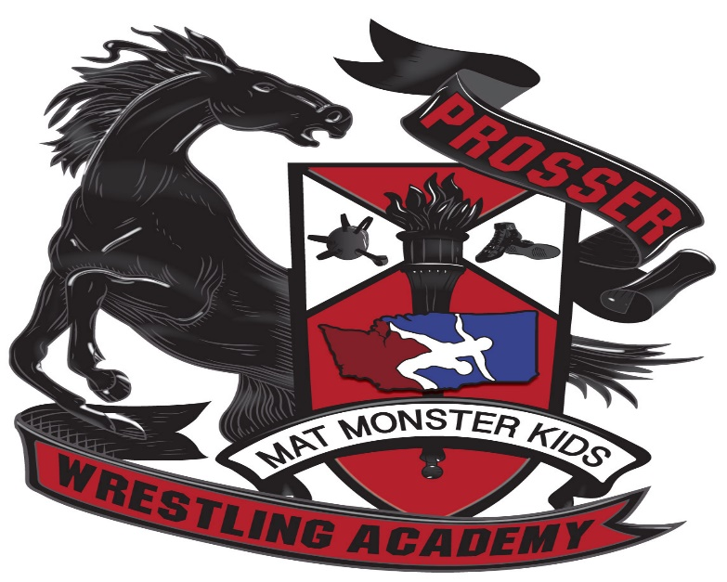
NOV,26,2022

LOCATION: PROSSER HIGH SCHOOL 1500 PATTERSON RD, PROSSER WA 99350
WEIGH INNS: 8AM-9AM
WRESTLING STARTS @10AM
ENTRY FEE: $25 PER WRESTLER

