BENTONVILLE
THANKSGIVING THROWDOWN
 | (Clubs pay with one check payable to BHS Wrestling)
ENTRY DEADLINE: | Thursday, November 24, 2022, at Midnight
WEIGH-INS: | Friday, November 25, 6-7:00pm at Bentonville High School
 | Wrestlers must wear singlet to weigh in.
 | NO SATURDAY WEIGH-INS.
 | Remote weigh-ins available—please call or email to confirm. Send an email after your remote weigh in Friday night.
CONTACT: | Jason Adams (918) 774-8881 jadams@bentonvillek12.org
 | Henry Reyes (479) 223-9289 hreyes@bentonvillek12.org
SCHEDULE: | Wrestling begins at 9am. Bentonville High School Main Gym
ADMISSION: | $5 Adults, $3 Students; Doors open at 8am
 | Concessions will be available.
 | (Hospitality room available only for coaches, referees, and workers.)
AWARDS: | Champions will receive a trophy, 2nd-4th places will receive medals.
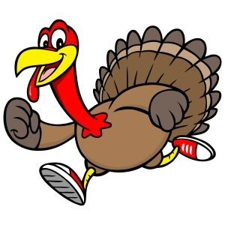
YOUTH WRESTLING TOURNAMENT Saturday, November 26, 2022
LOCATION: Bentonville High School Main Gym
1801 SE J Street, Bentonville, Arkansas 72712

ENTRY FEE: $20.00 per entry (Double entries welcomed)

Register online at trackwrestling.com (pay onsite)

AGE GROUPS & WEIGHT CLASSES (based on age as of Sept. 1, 2022)
We reserve the right to combine weights. Any weight with 6 or less entries may be round robin format or combined with weight above or below. We want kids to get as much wrestling as possible!

Division 1 (6U) 37, 40, 43, 46, 49, 52, 55, 60, 66, HWT
Division 2 (8U) 46, 49, 52, 55, 58, 61, 64, 67, 70, 75, 83, 90, 100, HWT
Division 3 (10U) 58, 61, 64, 67, 70, 73, 76, 80, 85, 90, 100, 115, 131, HWT
Division 4 (12U) 68, 71, 74, 78, 82, 86, 91, 96, 103, 110, 120, 132, 145, HWT
Division 5 (14U) 86, 94, 100, 106, 113, 120, 126, 132, 138, 145, 152, 160, 182, HWT

The Bentonville School District and Bentonville High School are not responsible for any accidents, injuries, or lost items. This tournament will be held regardless of weather conditions.

