AYWO-AAU Battle at the Beach
November 26th, 2022
Orange Beach High School
23908 Canal Rd Orange Beach, AL 36561
Google Map
Please Read Entire Flyer & direct questions to your coach.
They are your best source of information.

DISCOUNT ROOM LINK: https://www.gulfshores.com/events-calendar/sports-commission-website-event/2022-battle-at-the-beach-youth-wrestling/

We continue Gladiator series with the Gladiator’s Trident. This week’s coliseum battle takes place in the battle grounds of Orange Beach, AL. Come out to showcase your engrained wrestling skills that you will unleash on the mat!

This week the best of the best will be awarded with custom engraved Trident to the Outstanding Wrestlers and Most Valuable Wrestler in each age division. The tridents are a useful offensive tool for Gladiators. The tridents were designed to take the attack the gladiator’s opponent from a distance, aiding them in keeping out of sword range.
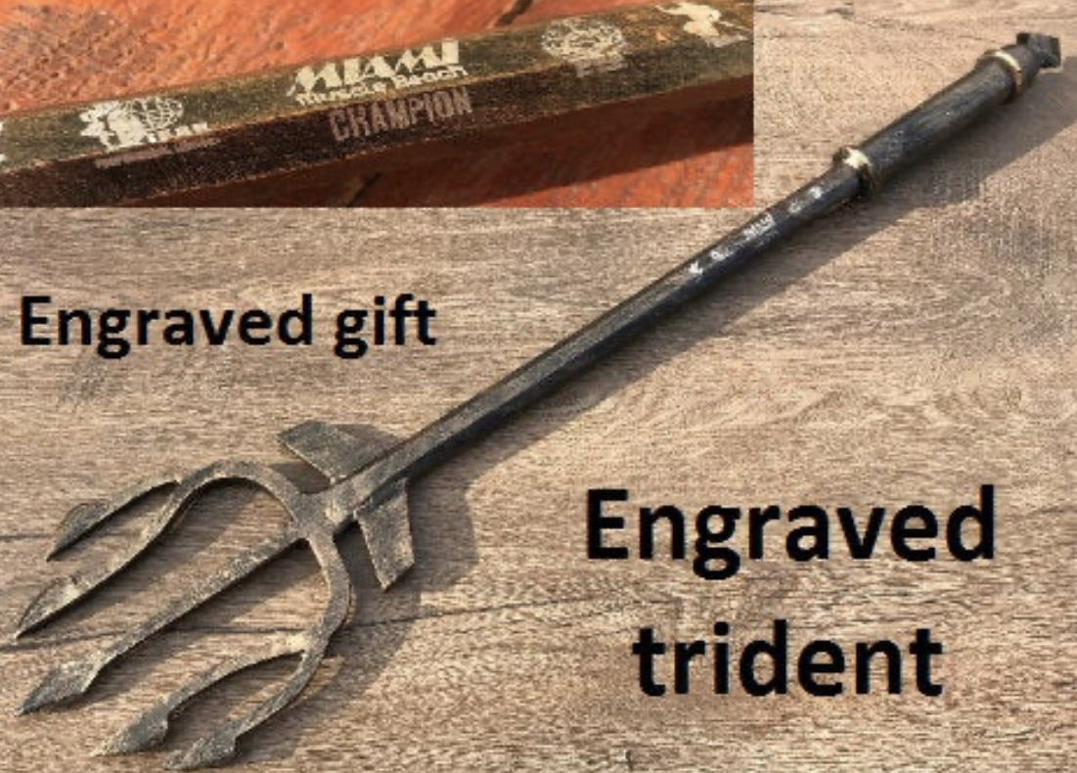
It's time to GLADIATOR up and show what you're made of! Come take part in the best run tournament in Alabama.

Criteria for Most Valuable Wrestler / Most Points: *Advanced brackets only* Most amount of points for the tourney and must be champion of their bracket.
Criteria for Most Outstanding wrestler / Most Pins: *Advanced brackets only* Most number of pins and must be champion of their bracket.

* In the event of a tie the wrestler with the least amount of time on the mat will be selected.
*A wrestler may earn 1 Gladiator award per event*
Wrestlers will need their AAU Card and Trackwrestling number to pre-register. Tournament fee is paid online. Each wrestler may compete in one weight class in two age divisions. When pre-registering, each wrestler is required to select a skill level. Any time there are four or more beginners in a weight class they will have a separate bracket. Beginner brackets run thru the end of December. *A beginner is a 1st or 2nd year wrestler who has not placed top 4 in a non beginner bracket.

Registration cost: $17.00
Pre-Registration DEADLINE: Friday November 25th at 2:00 pm CST
Any registration after 2 pm CST will cost: $30.00 Pre-Register Now!
Entrance Fees: $5 per person, under 3 free *** CASH ONLY ***

Tournament Host: Brent Pinkston, brentpinkston@yahoo.com
Tournament Operations Director: Ben Wanagat / Matt Gilson

Weigh-in Friday at a remote site or Saturday at the tournament location.

***NEW THIS YEAR*** Tot weigh-ins
Beginning this year Tot wrestlers will weigh-in. They can weigh-in Friday nights at an approved weigh-In location, listed below or Saturday morning onsite.
***NEW THIS YEAR*** Girls Only
The girls only wrestling will begin at 3:45 pm. We will create groups based off of weigh-Ins and may combine an age division up to get matches for the wrestlers.

Friday Night Remote Weigh-in locations: (All wrestlers)
Friday night from 6-8 PM:
Host Location
Bob Jones High School – Matt Sweatman and Ken Clark: 650 Hughes Rd Madison, AL 35758
Auburn Takedown Wrestling Club – Clement Tanaka: 1701 Lee Road 10, Auburn, AL 36832
Assassins Wrestling Club - Kyle Stiffler: 4620 County Rd 610 Enterprise, AL 36330
Bayside Academy --Brent Pinkston: 303 Dryer Ave Daphne, AL
Arab Knights -- Ray Galyean: 511 Arabian Dr NE, Arab, AL 35016
Birmingham Wrestling Club – Shad Rissler: 100 Old Town Rd Suite 100, Vestavia Hills, AL 35216
Wetumpka High School Field House – Brian Barrett: 1251 Coosa River Parkway Wetumpka, Al 36092

Saturday: On Site Weigh-in
All age groups weigh in. Weigh-Ins will begin 1 hour and 15 min prior to start time of each age division and will end 30 min prior to start time. 1 lbs allowance for onsite weigh-ins. Each wrestler must weigh in during their appointed weigh in times. After the weigh-in is closed, any wrestler that misses the weigh-in can bump up to the next division.
*Wrestlers are allowed to weigh-in on either Friday OR Saturday. They may not weigh-in twice*

Information
Only coaches and upcoming wrestlers are allowed on the mat. No Exceptions.
AYWO Standards will be used for age divisions and weight classes.
The wrestle-back format will be used to determine a true second place finish.
Coaches must maintain a visible AAU Card and must provide proof of the completed CDC Concussion training (yearly renewal) to be allowed on the mats and in the hospitality room.
Only two coaches are allowed in the corner during a match.
There are no refunds for this event.
If your wrestler exceeds the max weight allowed for a division, the wrestler must wrestle up in the next age division.
Hospitality will continue to be provided free-of-charge for coaches on the Club Coach List, as identified by designated wristband. Any coaches exceeding the club list must pay a $15.00
Out of State coaches please send coaching credentials to the Tournament Host

Saturday November 26th Wrestling Schedule
TOT Division Born 1/1/2016 – 12/31/2019: Wrestling begins at 9:00 am – 11:00 am
Weigh in: 7:45 am to 8:30 am
35, 40, 45, 50, 55, 60, 65, 75, 75+(max 90)

SCHOOLBOY Division Born 1/1/2008 – 12/31/2009: Wrestling begins at 9:00 am – 11:00 am
Weigh in: 7:45 am to 8:30 am
70, 75, 80, 85, 90, 95, 100, 105, 110, 115, 120, 125, 130, 135,140,145, 152, 160,171, 189, 220,250

BANTAM Division Born 1/1/2014 – 12/31/2015: Wrestling begins at 11:15 am – 1:15 pm
Weigh in: 10:00 am to 10:45 pm.
40, 45, 50, 55, 60, 65, 70, 75, 80, 90, 105, 115, 115+ (max 130)

MIDGET Division Born 1/1/2012 – 12/31/2013: Wrestling begins at 1:30 pm – 3:30 pm
Weigh in: 12:15 am to 1:00 pm.
50, 55, 60, 65, 70, 75, 80, 85, 90, 95, 103, 112, 120, 130, 150, 150+ (max 180)

NOVICE Division Born 1/1/2010 – 12/31/2011: Wrestling begins at 3:45 pm – finish
Weigh in: 2:30 pm to 3:15 pm
60, 65, 70, 75, 80, 85, 90, 95, 100, 105, 112, 120, 130, 140, 150, 150+ (max 180)

Girls Only – All Ages: Wrestling begins at 3:45 pm – finish
Weigh in: 2:30 pm to 3:15 pm

************************************************************************************************************
This event is licensed by the Amateur Athletic Union of the U.S.,Inc.
All participants must have a current AAU membership.
AAU membership is not included as part of the entry fee to the event.
AAU Youth Athlete membership must be obtained before the competition begins. BE PREPARED!
**Adult and Non-Athlete memberships are no longer instant and cannot be applied for at event. Please allow at least 10 days for membership to be processed.

