4th Annual BULLDAWG BASH
A SAWA Youth Wrestling Tournament &
TOC QUALIFIER
TOC WEIGHTS: 70,76,83,89,95,100,103,108,112,116
122,128,135,142,153,168,185,205,235

Weigh-ins times and location TBA

Hosted by: Alpha Dawg Wrestling

Date: Sunday, December 4th, 2022

Time: Doors Open at 8 AM
9 AM Start: Rookie (6U), Bantam (8U) and Intermediate (10U)
11 AM Start: Novice (12U), Middle School/TOC

Location: Folsom High School
1655 Iron Point Rd, Folsom, CA

Style: Folkstyle
Registration: $30/wrestler
Register Through Trackwrestling
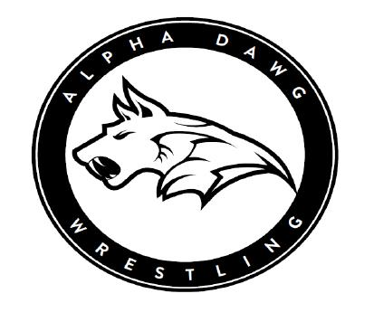
Questions: alphadawgwrestling@gmail.com

