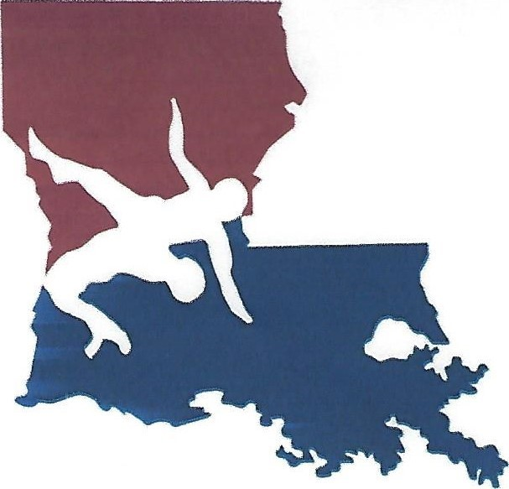

2 0 2 2 L A U S A F r e e s t y l e a n d G r e c o – R o m a n C h a m p i o n s h i p s
Host: East Ascension Wrestling / BRAWL Wrestling Club
When: Saturday, May 21, 2022
Weigh-ins: Friday, May 20, 2022 6 p.m. to 9 p.m.
Saturday, May 21, 2022 7 a.m. to 8 a.m.
Start Times: Freestyle: 8:30 Greco-Roman: at the conclusion of Freestyle
Divisions: 8U. 10U. 12U. 14U, 16U, JUNIOR
I WILL ONLY COMBINE WEIGHT CLASSES IF NECESSARY
Entries: due NLT 7:00 p.m., Friday, May 20, 2022
Entry Fee: $30.00 per wrestler (includes both styles)
All checks made payable to East Ascension Wrestling
Awards: individual medals for 1st, 2nd, 3rd place
OW trophies for each division
Hospitality: There will be a coach’s hospitality room available to coaches who have an updated coach’s card
Gate: Tickets can be purchased at the following link:
http://secure.payk12.com/school/_/153/item/220485

Feel free to contact Coach Mahoney at 225-954-7804 or Patrick.mahoney@apsb.org if you have any further questions.

