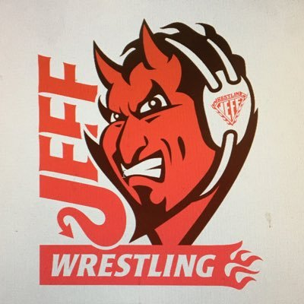
(click to register)
Freestyle Friday 6pm to ?, Saturday 9am Greco, Folkstyle begins 45 minutes after Greco
Girls Freestyle to run at the same time as Greco on Saturday morning
LIMITED TO THE FIRST 300 WRESTLERS (SIGN-UP EARLY!)

LOCATION
Jeffersonville High School, 2315 Allison Lane, Jeffersonville IN 47130– enter door 15

CONTACT: Danny Struck 812-786-2308 dstruck@gccschools.com

SANCTION – ELIGIBILITY
Tournament is sanctioned through the Indiana State Wrestling Association by USA Wrestling and is open to all current USA Wrestling members

ENTRY FEE
$20.00 for one style $30 for both, $40 for all three (paid on www.trackwrestling.com only)
NO additional fee for weight change

AGE DIVISIONS 6U (PEE-WEE) – 18U (Junior)

REGISTRATION & WEIGH-INS
Jeffersonville is on Eastern Time – Same as Indianapolis & Louisville; One hour ahead of Evansville
All times listed are EST times
All wrestlers must be registered on www.trackwrestling.com by 8:00pmThursday, 4/7/2022
No On-Site Registrations Out of state wrestlers welcome
USAW cards must be purchased at iswa.com. Cards not required to be shown onsite.

Weigh-ins and Skin Checks:
ONSITE: Friday 5pm, Wrestle 6:30pm Saturday - 7:30-8:30am, Wrestle at 9:30am
SATELLITE: Weigh-ins Must be approved but encouraged- Contact Coach Struck - must be a club weigh in, not an individual - Spreadsheet with Names, age group, USAW#, Weight class, and actual weight, club name - Wrestlers must be wearing a competition singlet for weigh-ins and skin checks
All wrestlers must check in by 6pm Friday, and 8:30am Saturday
Wrestlers who have not checked in PRIOR TO 8:30 am will be scratched from the tournament
Wrestling starts at 9:30am (be prepared to start early)
AWARDS Medals for 1st 2nd 3rd places; Ribbons for 4th 5th 6th
ADDITIONAL INFORMATION
Spectator Fee: $10.00 per person; $3 for 7 and under Cooler Fee: $5.00; Concessions available on-site

