SC USA Wrestling- Easley Ironman. 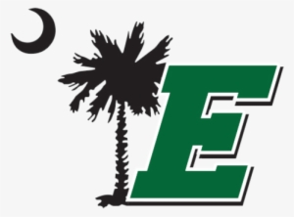
Folkstyle/ Freestyle/ Greco Roman /Girls Wrestling
Location: Easley High School, 154 Green Wave Blvd, Easley SC 29642
Date: 03/19/2022
Weigh In/ Skin Check: 7-8:30am
Coaches Meeting/rules clinic: 8:30 am
Wrestling starts at 9am
Gate: $5 per person
Medals will be presented to the top 3 wrestlers in each bracket.
USA Wrestling Membership cards will be checked at the gate. Coaches will receive a wrist band (required to be matside).
All wrestlers must pre-register and make their registered weight to participate in the tournament. Register at Trackwrestling.com- Events- Tournament Name. Registration fee is $10 for Folkstyle, $10 for Freestyle, and $10 for Greco.
Contact information
Host: Randy Merchant 864-991-9214
Registration: Gova chrobocinski 843-826-7898 scusaw@gmail.com

2022 Tournament Schedule
Mar 19st | Easley Ironman | Easley High School
Mar 26th | Pelion Ironman | Pelion high school
April 2nd | Lexington county ironman | Pelion High school
April 9th | The Island Slam | Hilton head high school
April 16th | Palmetto state Ironman | Woodmount high school
April 23rd | Greenwood Ironman | Greenwood high school
April 30th | West Oak Ironman | West Oak High school
May 7th | SC USA Wrestling Folkstyle State | High Point high school
May13th-May 15th | USA Wrestling Southeast Regionals | Cherokee north Carolina
May 21st | Army National Guard Ironman | Columbia South Carolina
May 28th | Legacy Elite Ironman | Fort dorchester High school
June 4th | SC USA Wrestling State Freestyle and Greco | South Florence high school

