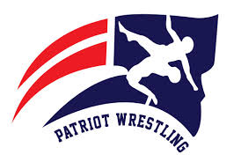
Inaugural Ramsie Kate JV Invitational Tournament
& North Vermilion Middle School / USAW Tournament
North Vermilion High School
Schedule: Saturday February 5th 2022
Weigh in: 8:00 am
Wrestling: 9:00 am
Tournament is open to all new wrestlers or min experience 9th-12th
Wrestlers who will not compete at state tournament or the coach feels as though they would not compete very well are invited. (Please use good judgement) Wrestlers will be placed in random generated brackets
There will be a mat for USA wrestlers (5th-8th grade, must have current USA card to compete) We will match the USA wrestlers based on weight and grade and they are guaranteed 2 matches. This is a separate tournament and will be on track wrestling.
Entry : High School $10 per wrestler (not to exceed $130)
USA wrestlers $5 per wrestler
Make checks payable to North Vermilion High School
11609 LA-699
Maurice, LA 70555

Medals will be given to 1st and 2nd place for JV tournament

Enter the wrestlers on Trackwrestling for both tournaments by Thursday Feb. 3rd, 10pm
Gate Entry fee: $7.00, concessions will be sold
Call or text Coach Brandon Billeaud 337-654-2522
brandon.billeaud@vpsb.net, bguidroz@att.net

