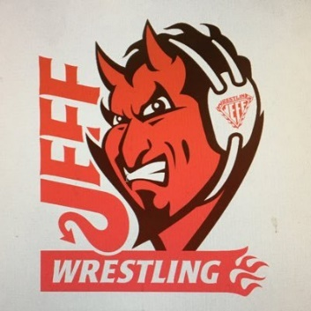

TEAM JEFF FOLKSTYLE OPEN
Sunday, January 23, 2022
LIMITED TO THE FIRST 300 WRESTLERS (SIGN-UP EARLY!)

LOCATION
Jeffersonville High School, 2315 Allison Lane, Jeffersonville IN 47130– enter door 15

CONTACT: Danny Struck 812-786-2308

SANCTION – ELIGIBILITY
Tournament is sanctioned through the Indiana State Wrestling Association by USA Wrestling and is open to all current USA Wrestling members

ENTRY FEE
$20.00 (paid on www.trackwrestling.com only)
NO additional fee for weight change

AGE DIVISIONS 6U (PEE-WEE) – 14U (Schoolboy/girl)
Indiana Middle School wrestlers are encouraged to sign up for the Middle School State South Qualifier that will be run simultaneously at our site.
Click Middle School State South Qualifier Registration to register

REGISTRATION & WEIGH-INS
Jeffersonville is on Eastern Time – Same as Indianapolis & Louisville; One hour ahead of Evansville
All times listed are EST times
All wrestlers must be registered on www.trackwrestling.com by 8:00pm Friday, 1/21/2021
No On-Site Registrations Out of state wrestlers welcome
USAW cards must be purchased at iswa.com. Cards not required to be shown onsite.

Weigh-ins and Skin Checks:
Sunday - 7:30am ON SITE
Satellite Weigh-ins Must be approved - Contact Coach Struck.
Wrestlers must be wearing a competition singlet for weigh-ins and skin checks
All wrestlers must be checked in by 8:30 am on Sunday
Wrestlers who have not checked in PRIOR TO 8:30 am will be scratched from the tournament
Wrestling starts at 9:30am (be prepared to start early)

AWARDS Medals for 1st 2nd 3rd places; Ribbons for 4th 5th 6th

ADDITIONAL INFORMATION
Spectator Fee: $10.00 per person; Cooler Fee: $5.00; Concessions available on-site

