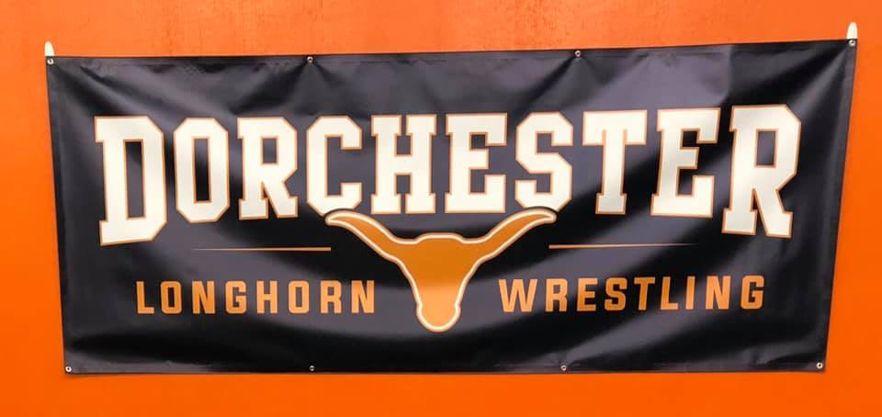

DORCHESTER WRESTLI NG CLUB TOURNAMENT

DATE: Saturday, January 29th, 2020
LOCATION: Dorchester Public School
ENTRY FEE: $16.00 on line at Track Wrestling ,$20.00 walk-ins (NO REFUNDS) Online Payment Only https://www.trackwrestling.com/opentournaments/MainFrame.jsp?newSession=false&TIM=1578602392854&pageName=

ENTRY DEAD LINE: Friday January 28th, 2020 at 6p.m.
AWARDS: Trophies for the first place, medals for 2nd,3rd,& 4th places
SCORING: Huskerland Modified Folkstyle Rules.

ADMISSION: Adults-$5.00,students-$3.00, 6 and under free
Concessions will be available. No coolers or drinks will be allowed in gym.
TOURNAMENT DIRECTOR: TODD JENSEN – 402-641-2047 or tajensen85@gmail.com
WEIGH-IN AND WRESTLING TIMES

Grades Weigh-ins Wrestle
Pre k-k 7:00 - 8:00 a.m.1 9:00 a.m.
1st-2nd close at 8.30 a.m . 9.30 a.m.
3rd – 4th close at 9:00 a.m. At conclusion of pre k-2nd
5th – 6th close at 11:00 a.40m. At conclusion of 3rd – 4th
7th – 8th close at 1:00 p.m. At conclusion of 5th – 6th

PLEASE NOTE: No late weigh-ins without prior approval. Coaches Meeting is at 8:30 a.m.

WEIGHT CLASSES: 4 – man round robin brackets. No set weight classes. There may be less than 4 - man brackets to maintain weight differential.

Please contact Matt Smith 402-826-9303 or smith_4_34@hotmail.com with any questions or requests for additional information.

