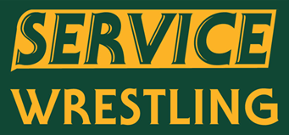
Herm Jones JV Wrestling Tournament
When:
Saturday December 4th. 2021
Weigh ins at 7:30AM, Wrestling Starts at 9:00AM
Where:
Service High School Main Gym
General Information:
- This is a JV tournament. Any Wrestler Eliminated from the Grace Grizzly Shakedown can attend, Coaches discretion – please only JV level wrestlers
- Entries into TrackWrestling are due by 8:00PM on Friday Night
- There will be a Concession stand for fans and participants and a hospitality room for coaches
- Entry Fee: $20.00 per wrestler
- If you are interested, please contact Coach Banning for more information at servicewrestling@gmail.com

