Buchholz IOF

“I Own Florida”

AAU Wrestling
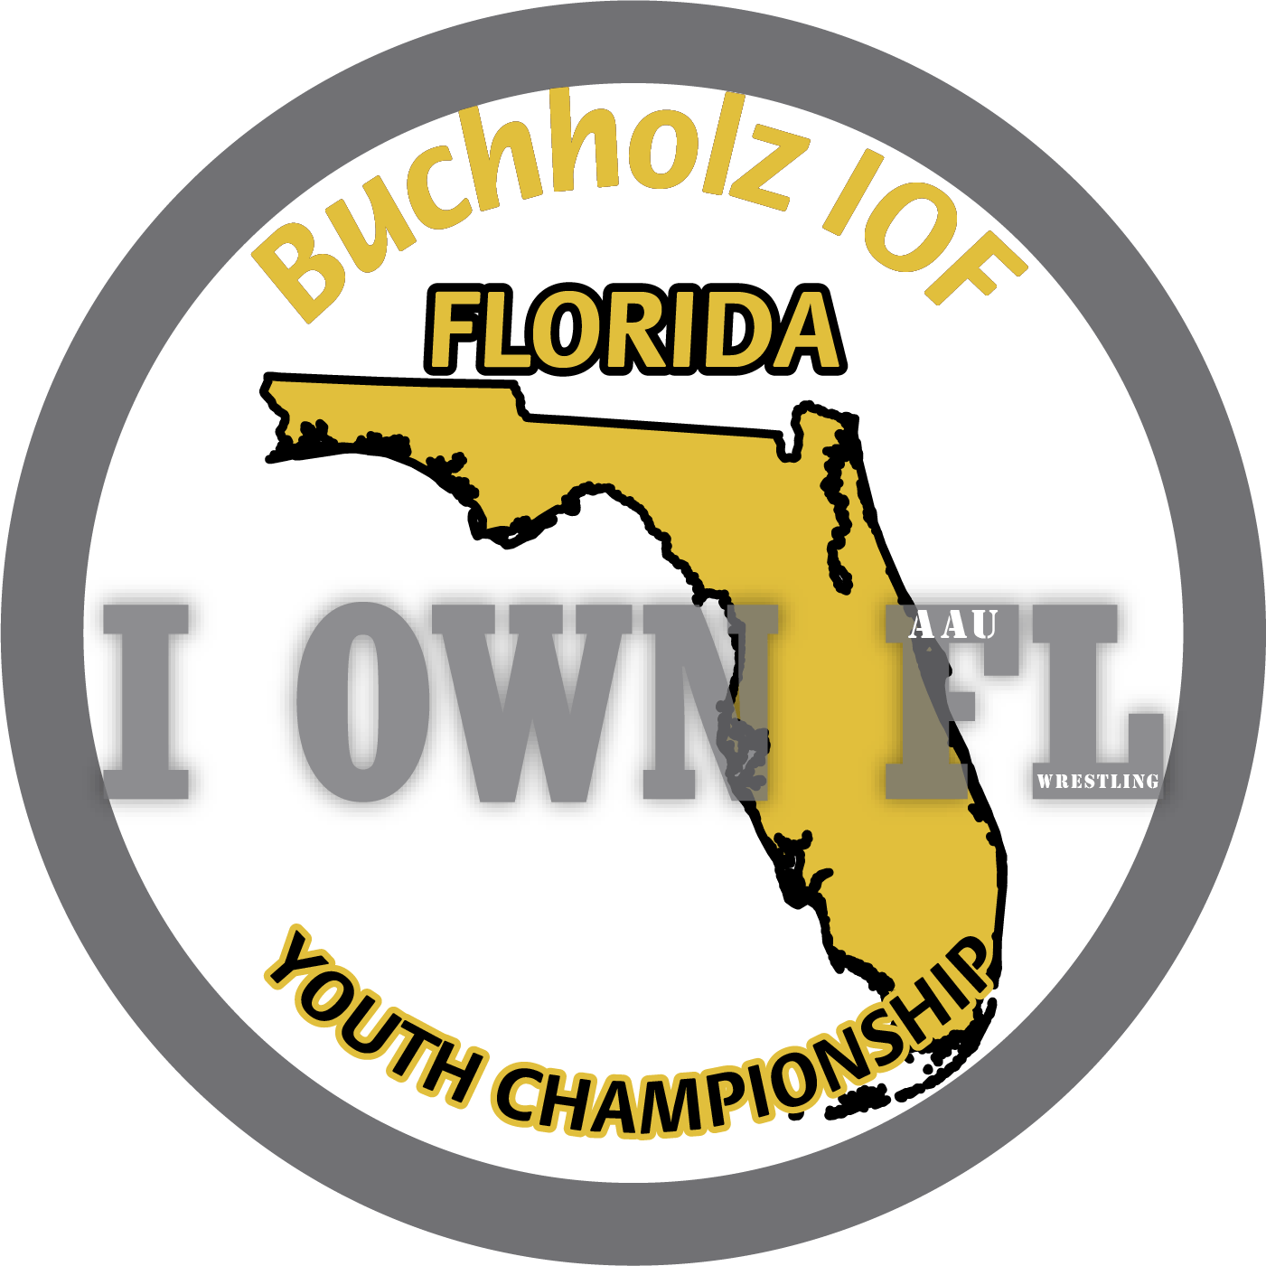

DATES: Sunday December 5th , 2021
LOCATION: 5510 NW 27th Ave, Gainesville, FL 32606
HOSTS: email: Thomas Pankey pankeytw@gm.sbac.edu
ENTRY FEE: Pre-register $20 Late (onsite) Registration $30 Extra Entries: $20
WEIGH-INS: 8am-9am wrestling begins at 10am
REGISTRATION: Must pre-register on Trackwrestling.com

AAU 2021-2022 “IOF” Age Divisions & Weight Classes are posted on Trackwrestling when you pre-register for an event

For information on weigh-in and start times, directions to tournaments, and other general information on each event contact the specific event directors.
This event is licensed by the Amateur Athletic Union of the U.S.,Inc.
- All participants must have a current AAU membership.
-AAU membership may not be included as part of the entry fee to the event.
-AAU Youth Athlete membership must be obtained before the competition begins.
-BE PREPARED! Adult and Non Athlete memberships are no longer instant and cannot be applied for at event.
-Please allow at least 10 days for membership to be processed.
-Participants are encouraged to visit the AAU website www.aausports.org to obtain their membership.

FOR MORE INFORMATION: Thomas Pankey pankeytw@gm.sbac.edu

