2nd Annual Worthington Youth Wrestling Association Tournament
Worthington High School Gym
1211 Clary Street, Worthington, MN 56187
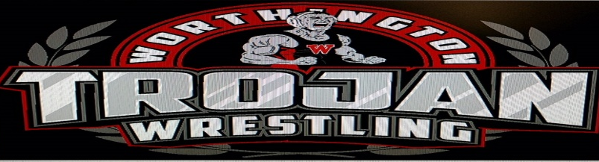

Date: Friday, December 3rd, 2021
Registration: All wrestlers must Pre-register on Trackwrestling, under tournament name. No registrations at the door. Pre-register by noon, Wednesday, December 1st. Must be within 3 lbs of selected weight, brackets will be pre-built.
Weigh-Ins: 4:30pm-5:30pm; Wrestling begins at 6pm
Entry fee: $12.00 per wrestler Spectator Admission: Adults-$5, Students-FREE
Medals will be awarded for all wrestlers. Four to five man round-robin brackets (when possible), three 1-minute periods, MSHSL rules. one coach per mat/wrestler. The official’s decision is FINAL! Arguing will not be tolerated. Brackets will remain mat side until done wrestling, and then proceed to awards.
Concessions will be available—no coolers please.
For more information contact: Dusty Neugebauer (507) 360-7590, Travis Dagel (507) 360-2782 or
Jesse Larson (507) 329-0181
E-mail: dusty.neugebauer@plantpioneer.com
---------------------------------------------------------------------------------------------------------------------------------------
INDIVIDUAL TOURNAMENT WAIVER – Bring to weigh in’s
NAME: ____________________________________________________ AGE: __________________
DATE OF BIRTH: ___________________ WRESTLING CLUB/SCHOOL: __________________________
GRADE (CIRCLE ONE): PK - K 1 - 2 3 - 4 5 - 6
SKILL LEVEL (CIRCLE ONE): GOOD AVERAGE BEGINNER
NOTICE TO PARENT/GUARDIAN: I certify that _______________________________was born on the date stated, and has my permission to compete in the Worthington Youth Wrestling Tournament. I also certify that he/she is in the __________ grade. I hereby accept full responsibility for his/her behavior and for his/her participation. Obedience and good sportsmanship will be displayed throughout the day. I agree to not hold the Worthington Youth Wrestling Association, Worthington Public Schools, or any of their agents responsible for any injuries or accidents that could or may occur.
SIGNED: _______________________________________ DATE: ___________________________

