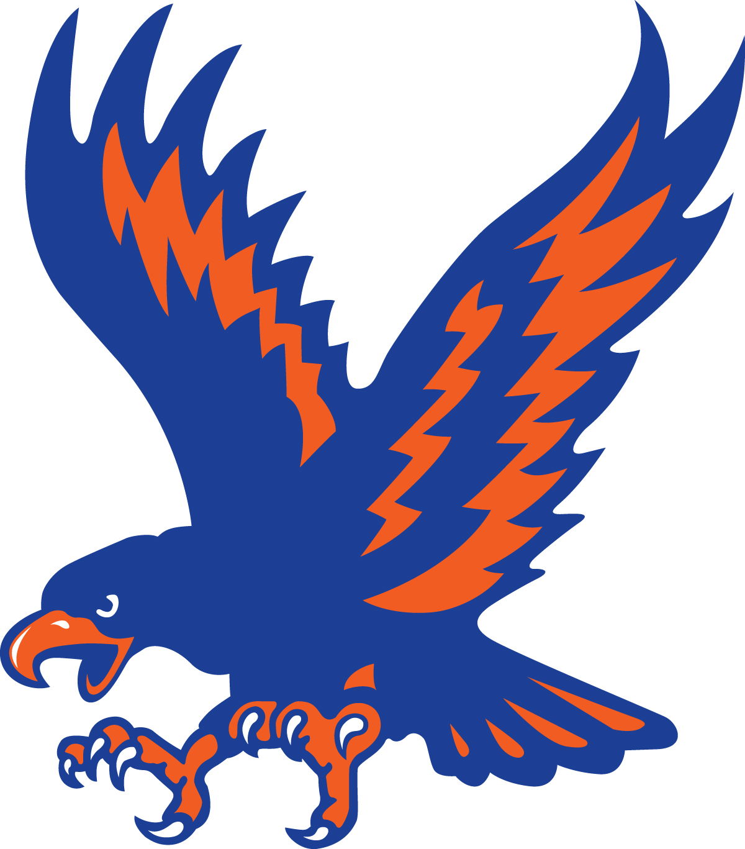

Little J-Hawk
Wrestling Tournament
Sunday, December 5, 2021
Pre-Kindergarten through 8th Grade

When and Where: Jesup High School, Jesup, Iowa on Sunday, December 5, 2021
Entry Fee: Pre-Register $15. Walk-ins $20 (No insurance, No refunds) (Limited to the 1st 400 entries) Register at Trackwrestling.com----Pre-registration will close on 12/4/2021.
Link: http://www.trackwrestling.com/registration/TW_Register.jsp?tournamentGroupId=197084132
Make checks payable to Jesup Booster Club
Contact: Kristin Schutte (319) 239-8487 or schutte05@gmail.com
Spectator Admission: $5.00 for adults / $2.00 for students / 4 and under free. Full concession stand will be available.

Weigh-ins: Weigh-ins for PK-4 grade from 8:00 am to 9:30 pm (SHARP)!! Wrestling will begin at 10:30am Weigh-ins for 5-8 grades from 12:15 pm to 1:15 pm (SHARP)!! Wrestling will begin at 2 pm
Matches: Wrestlers will wrestle in 4-man or 5-man round robin brackets. Hopefully no byes will be necessary and pairing of wrestlers from the same town can be avoided.
Matches will be 1-1-1 except for the Senior Division which will be 1:30-1:30-1:30 If necessary, junior and senior divisions will have overtime. We make every effort to assure evenly matched competition. Please be honest with your wrestler’s skill level.
Divisions: Super Pee Wee (PK-K) Peewee (1-2); Novice (3-4); Junior (5-6); Senior (7-8).
Awards: First (medal & chart); Second – Fifth (medals)
Snow Date: Every attempt will be made to hold the tournament. If cancellation is necessary due to bad weather KWWL will be notified.
By registering for this event you certify that the person registered is in the assigned grade and has your permission to compete in the Little J-hawk Wrestling Tournament. I hereby accept full responsibility for his/her behavior and for his/her participation. I agree not to hold the Jesup Schools and /or the Jesup Booster Club, or any of either group’s members/employees responsible for injury or accident to my youngster. I understand that neither is carrying medical insurance to cover my youngster.

