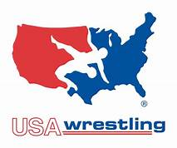BATTLE AT THE BAY

DATE: October 16, 2021
LOCATION: CYPRESS BAY HIGH SCHOOL
18600 VISTA PARK BLVD
WESTON FL. 33332
Weigh-In: 8-10 am / Wrestling starts at 11
Entry Fee: $20 entry fee for each weight or division
USA Card is required…Please register online…
FLORIDAAMATEURWRESTLING.ORG
Pee Wee - Novice, Middle School, JV, Varsity, Girls, State Level
HIGH SCHOOL WT CLASSES
GROUP WEIGHTS if NEEDED
AWARDS FOR TOP THREE
QUESTIONS- ALLEN HELD 954-854-1124 LEAVE MESSAGE
ALLEN.HELD@BROWARDSCHOOLS.COM

