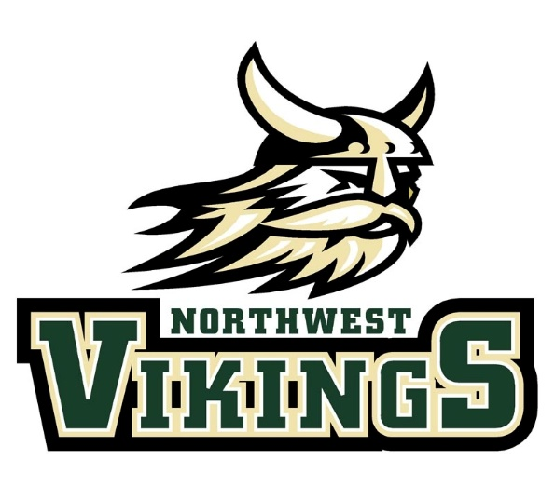
Northwest Viking Takedown Invitational
Saturday November 6, 2021
Mass Hydration beginning @ 0630
Coaches Meeting @ 0730
Wrestling starting @ 0900
- This tournament will be run on Track Wrestling and will be a pool tournament with medals going to the undefeated wrestler in each pool. You will need to enter your wrestlers into the Track Wrestling event prior to the 6th
- We will use satellite weigh-ins, all you need to do is know the weight of your wrestler and input them into Track Wrestling.
- The classes will be separated in no more than 10 pound increments
- Entry fee will be $10 a wrestler and the admission will be $8 per person, children 7 and under admitted free
- The boys will be split between beginner and experienced. We will have a running clock of 3 minutes and scored on takedowns only
- Depending on the amount of girls in the tournament we can split them between experienced and beginner. We will have a 3 minute running clock and scored on takedowns only
Contact Information:
Chris Bedell- christopher.bedell@cmcss.net
931-449-9794

