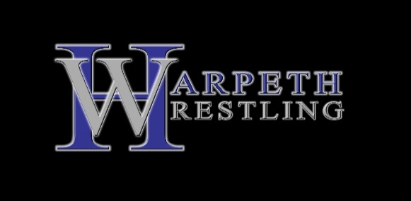
Summer Bash
Saturday, July 24, 2021
Harpeth High School
170 East Kingston Springs Road
Kingston Springs, TN 37082

Style: Modified Freestyle

Weigh-ins: 8:00 a.m.

Wrestling: 9:00 a.m.

Divisions: Middle School and High School Boys and Girls

Periods: 1 three minute period (running clock) w/ Sudden Death Overtime and 10 point Tech Fall

Entry Fee: $25 per wrestler (can only be paid online at trackwrestling.com)

Admission: $5 per person (can only be paid online; use the following link)
https://checkout.square.site/buy/GPGHAZV2YZ5VIJKUGYWCG4ZY

There will be a light concession stand

For more information contact Joe Whitlow at Harpethtakedownclub@gmail.com

Boys Middle School (6-8): 72, 82, 90, 98, 106, 114, 122, 130, 138, 148, 158, 175, 190, HWT
Girls’ Middle School (6-8): 60, 70, 80, 90, 105, 120, 140, 160, 200
Boys’ High School (9-12): 106, 113, 120, 126, 132, 138, 145, 152, 160, 170, 182, 195, 220, 285
Girls High School (9-12): 103, 112, 119, 125, 132, 140, 150, 160, 170, 190, 285

Tournament director reserves the right to change/combine weight classes and divisions to maximize the opportunities for the wrestlers.

